**Index**

**Name Page No.**

1. Front Page i
2. Acknowledgement ii
3. Certificate of Training iii
4. Index /list of figures 1
5. Company Introduction 2
6. Weekly schedule in organization 5
7. Introduction about project/Course contents 6
8. Detailed about project/course contents 9
9. Application Screenshots 21
10. Database Screenshots 34
11. Coding 41
12. Future Scope of Project 104
13. Bibliography 105
14. Company contact details 106

**Company Introduction**

**Introduction**

Incorporated on 19 March, 2002, **info-net ACADEMY OF COMPUTER AND EDUCATION** is the parent company of the group. It is an established and recognized computer institute providing all types of computer education courses and university courses. Company aim at providing quality education at very economical rates to students of all streams including higher classes & professional courses. Caste, color or age is no barrier for learning computers at **info-net** because we work with a motto **COMPUTER FOR EVERYONE.**

The academy had a placement wing from the very first day and efforts were always on to help and guide students regarding training and placements in and around the city, the outcome of which had been regular placements of the students in reputed companies. Finally 15 August 2004, a separate company was formed by the name of **info-net CONSULTANCY SERVICES** with a theme of **JOBS FOR EVERYONE.**

3 years later, on 01 April 2007 another venture of the group **info-net SOFTWARE SOLUTIONS** came into existence to cater to the needs of students from B Tech., MCA etc. providing them with project and summer trainings on advanced technologies and products. The company also provides Software Consultancy to its industrial and corporate clients in the fields of Software Development and Web Development.

The group has a registered office at Karnal, Haryana, INDIA, and planning to open various franchisee centers’ across the country in near future with major concentration on northern region of the country initially.

**Services**

|  |
| --- |
| The group provide all its candidates and customers with quality consultancy services in fields listed below through its multiple companies’ network.    http://infonetgroup.org/images/bullet1.jpg  Job Placements Services http://infonetgroup.org/images/bullet1.jpg  Study Visa Consultancy http://infonetgroup.org/images/bullet1.jpg  Software Development http://infonetgroup.org/images/bullet1.jpg Web Development    Hardware Consultancy http://infonetgroup.org/images/bullet1.jpg  Education Helpline  The **Job Placement** section is a direct service offered by the group company **info-net CONSULTANCY SERVICES**. A registered candidate gets its services for next six months. Market surveys for listing new openings are performed on regular basis. Fresh interviews in multiple categories are scheduled daily and best efforts are made to provide maximum placement opportunities to all candidates.    **Study Visa Consultancy** and **Immigration Services** are the two new ventures of the company. A candidate is provided support for document processing and interview preparation. The company has appointed a separate team to discover new destinations abroad.    The Web Development and Software Development are looked after by the group company **info-net SOFTWARE SOLUTIONS.** Itworks as a software development and consultancy company and provides requirement based solutions to clients. The orders are also outsourced to, our technology partner "**RBH Solutions Pvt. Ltd." Patiala**, for development and implementation.  The **Hardware Consultancy** and **Education Helpline** is a free of cost service offered to all students and candidates by the group companies **info-net CONSULTANCY SERVICES** and **info-net ACADEMY OF COMPUTER AND EDUCATION** respectively. Anybody approaching for it gets complete information related to his / her queries. |

**Tie Ups**

|  |  |  |  |  |  |  |  |  |  |  |  |  |  |  |  |  |  |  |  |  |  |  |  |  |  |  |  |  |  |  |  |  |  |  |  |  |  |  |  |  |  |  |  |  |  |  |
| --- | --- | --- | --- | --- | --- | --- | --- | --- | --- | --- | --- | --- | --- | --- | --- | --- | --- | --- | --- | --- | --- | --- | --- | --- | --- | --- | --- | --- | --- | --- | --- | --- | --- | --- | --- | --- | --- | --- | --- | --- | --- | --- | --- | --- | --- | --- |
| The group is today connected with employers from all walks of business in the country and the never ending hunt is still on for more exciting and enthusiastic working environments. **Info-netCONSULTANCY SERVICES** has a dedicated support team to cater to employment needs of our industrial and corporate clients in India and abroad. A few of our esteemed associate clients are listed below:    **Thapsons**, *Turning Point,* **GoodRich,** *BSNL,* **Cadbury,** *Bajaj Almond,* **Mr.Mucsle,** *Colgate,* **Henko,** *Sankalp Consumer Pvt. Ltd.,* **Easyway,** *More,* **Spencer,** *Vishal Mega Mart,* **Big Bazar,** *Reliance Telecom,* **Bharti Airtel,** *Tata Indicom,* **Vodafone,** *Hot Spot,* **The Mobile Store,** *Lava Mobiles,* **Horizon Computers,** *Samsung,* **LG,** *Videocon,* **Genpact,** *Mass Callnet India Pvt Ltd.,* **RBH Solutions Pvt. Ltd.,** *Best Food International*  .......and many more to make the list lengthy.    **So Far So Done**    The consultancy has received remarkable response and achieved success in acquiring employers’ belief and candidate satisfaction by regular interviews, immediate feedback and impressive results in the form of placements.  A few of our landmark achievements are as follows    **More than 700 tie ups in and around the state have been established so far.**    *Almost all trades of business and services such as banking, trading, finance, manufacturing, retail and marketing etc. have been included during the survey for job collection.*    **More than 2,250 candidates have been registered so far with the consultancy.**    *Over 13,200 interviews have been conducted at the employer’s location by the medium of consultancy.*    **And most of it 1,023 successful placements have been made so far.**  **About us**    The group works as a unit from two different campuses within in the Karnal city and is dependent upon sincerity, hard work and readiness of its team members for progress and growth. The efforts and dedication of the staff has helped us gain strengths and perform efficiently. Mentioned below are some important facts about us.   |  | | --- | | **Education Wing** | | |  |  | | --- | --- | | http://infonetgroup.org/images/bullet1.jpg | Well-equipped computer labs. | | http://infonetgroup.org/images/bullet1.jpg | Qualified, trained and experienced teaching staff. | | http://infonetgroup.org/images/bullet1.jpg | A 12 hour education helpline. | | http://infonetgroup.org/images/bullet1.jpg | Placement wing for employment solutions. | | http://infonetgroup.org/images/bullet1.jpg | Furnished theory rooms. | | http://infonetgroup.org/images/bullet1.jpg | Small size batches. | | http://infonetgroup.org/images/bullet1.jpg | Round the year support for university procedures. | | http://infonetgroup.org/images/bullet1.jpg | Individual attention to weaker students. | | http://infonetgroup.org/images/bullet1.jpg | Scholarships for meritorious and deserving students. | | | **Placement Wing** | | |  |  | | --- | --- | | http://infonetgroup.org/images/bullet1.jpg | Availability of jobs in multiple categories and trades. | | http://infonetgroup.org/images/bullet1.jpg | Separate wing to cater to needs of jobs abroad. | | http://infonetgroup.org/images/bullet1.jpg | Unique strategy of market survey to find new openings. | | http://infonetgroup.org/images/bullet1.jpg | Enthusiastic team of professionals in support staff. | | http://infonetgroup.org/images/bullet1.jpg | One time free resume and interview preparation. | | http://infonetgroup.org/images/bullet1.jpg | Special assistance in personality and outlook development. | | http://infonetgroup.org/images/bullet1.jpg | Exclusive immigration and study abroad visa services. | | | **Development & Training Wing** | | |  |  | | --- | --- | | http://infonetgroup.org/images/bullet1.jpg | S/w and Web Development outsourcing tie - ups with **"RBH Solutions Pvt. Ltd., Patiala, Punjab, India".** | | http://infonetgroup.org/images/bullet1.jpg | Exclusive Industrial Training programs for M.C.A 6th sem. & B. Tech. 8th sem. students. | | http://infonetgroup.org/images/bullet1.jpg | Project Based Summer Training programs for B Tech 4th or 6th sem. & Diploma 4th sem. students. | | http://infonetgroup.org/images/bullet1.jpg | Vocational Training programs for B.A. / B.Sc. / B.Com students. | | |

**Weekly Schedule in Organization**

|  |  |  |
| --- | --- | --- |
| S. No. | Date | Topic |
| 1. | 01/07/14 - 02/07/14 | Introduction to java |
| 2. | 03/07/14 - 04/07/14 | Constructors |
| 3. | 07/07/14 | Access specifiers & concept of packages |
| 4. | 08/07/14 - 09/07/14 | Constructor & function overloading |
| 5. | 10/07/14 - 11/07/14 | Inheritance |
| 6. | 14/07/14 - 15/07/14 | Concept of object class |
| 7. | 16/07/14 | Function overriding |
| 8. | 17/07/14 | Concept of final & static keywords |
| 9. | 18/07/14 - 19/07/14 | Interfaces & abstract classes |
| 10. | 21/07/14 - 22/07/14 | Handling strings in java |
| 11. | 23/07/14 - 24/07/14 | Exception handling |
| 12. | 25/07/14 | Concept of JavaBean& array |
| 13. | 28/07/14 - 29/07/14 | Collection framework & concept of stream classes |
| 14. | 30/07/14 - 31/07/14 | Concepts of threads & multithreading |
| 15. | 01/08/14 - 02/08/14 | JDBC |
| 16. | 04/08/14 | Applets |
| 17. | 05/08/14 - 06/08/14 | Swings |
| 18. | 07/08/14 – 15/08/14 | Project development |

**INTRODUCTION TO PROJECT**

**Introduction**

**Club Management System**is an application that is used to form various clubs and manage them in an organization. In it the information of the people (students) is entered and this information is stored in a central database and according to their interests various clubs are formedwhere people can join them. Also, various clubs can organize major and minor events in which various users and people of organization can participate. They can volunteer to manage them. Club Management System is an application used to all these databases of people and events. It is also used to manage the members of various clubs.

**It is developed using Java technologies.**

**Objective**

The **objective** of the application would be:

1. To motivate people to form various clubs according to their interests.

2. To increase the people’s participation in various activities.

3. Maintain and view various reports of various clubs.

4. Listing of people information.

5. Maintain the people records.

**Functionality**

1. **Login:** To access this application, users would be required to login through a login screen.

After authentication user would be able to access only those areas for which permissions are given.

**2. Options:** This allows the user to choose among various options likestudent and club registration also view and update them.

**3. Student Form:** This is used to save, view and update student details.

**4. CourseForm:** This is used to save, view and update course details.

**5. ClubForm:** This is used to save, view and update club details. It provides various options to the users and keep a track of all the clubs.

**6. Activity Form:** This is used to keep all the information regarding various activities organized by clubs.

**7. Event Form:** This form is used to keep track of the major event organized by various clubs like a yearly event.

**8. Participation Form:** This form is helpful in maintaining the record of all participants with date and all the information like the event in which they participate.

**Input Requirements**

1. User Login Details.

2. Club Details

3. Event Details.

4. Student Details.

5. Member Details.

6. Volunteer Details.

**Output Requirements**

1. Member Report.

2. Participants Report.

3. Volunteer Report.

4. Event Report.

**Users of the System**

The users of this system will be the users of the organization. The systems are menu driven to facilitate the users. The system is developed with the participation of users, which will help them to understand the system easily.

**Technologies Used**

**1. Java:**

Java is Platform Independent, Secure, Object Oriented, Scalable, and Robust Programming Language. It consists of two parts:

* JVM stands for Java Virtual Machine, which is run time environment to execute the java programs.
* Java API (Application Programming Interface) that consists of inbuilt classes used in java programs.

**2. JDBC (Java Database Connectivity)**:

It is an API, which is used for the communication of java programs with different databases.

**3. Windows Programming:**

**Swings**: Swings in java is a rich set of components for building GUIs and adding interactivity to java applications. Swing includes all the components that you would expect from a modern GUI toolkit that is table controls, list controls, tree controls, buttons and labels. The basic architecture of swing is MVC. And are entirely made in java.

**4. SQL Server Management Studio:**

SQL Server Management Studio is used as database, used to store data. It is RDBMS.

**Software Requirements**

1. **JDK 1.7**

* Notepad++.

2. **Database**

* SQL Server Management Studio.

3. **JDBC Driver for Database Server**

* SQL Server.

4. **Operating System**

* Windows Vista / XP sp3 / Win 8 / Linux Fedora/ Win 7.

**Hardware Requirements**

1. Intel P4 processor with minimum 2.0 GHZ Speed.

2. RAM: Minimum 512MB.

3. Hard Disk: Minimum 20GB.

**DETAILS ABOUT PROJECT**

**Technologies Used**

* **Java Technology:**
* ***The Java Programming Language***

Java technology is both a programming language and a platform.

The Java programming language is a high-level language that can be characterized by all of the following characteristics:

* Simple
* Object oriented
* Distributed
* Multithreaded
* Architecture neutral
* Portable
* High performance
* Robust

In the Java programming language, all source code is first written in plain text files ending with the .java extension. Those source files are then compiled into .class files by the javac compiler. A .class file does not contain code that is native to your processor; it instead contains *byte codes* — the machine language of the Java Virtual Machine (Java VM). The java launcher tool then runs your application with an instance of the Java Virtual Machine.

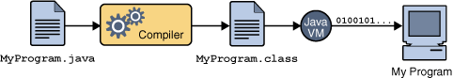

An overview of the software development process.

Because the Java VM is available on many different operating systems, the same .class files are capable of running on Microsoft Windows, the Solaris TM Operating System (Solaris OS), Linux, or Mac OS. Some virtual machines, such as the Java Hotspot virtual machine, perform additional steps at runtime to give your application a performance boost. This include various tasks such as finding performance bottlenecks and recompiling (to native code) frequently used sections of code.

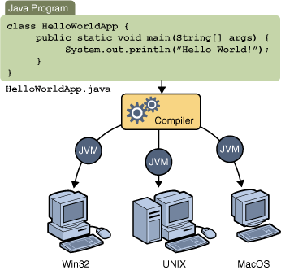

Through the Java VM, the same application is capable of running on multiple platforms.

### *The Java Platform*

A platform is the hardware or software environment in which a program runs. Most platforms can be described as a combination of the operating system and underlying hardware. The Java platform differs from most other platforms in that it's a software-only platform that runs on top of other hardware-based platforms.

The Java platform has two components:

The Java Virtual Machine

The Java Application Programming Interface (API)

Java Virtual Machine is the base for the Java platform and is ported onto various hardware-based platforms.

The API is a large collection of ready-made software components that provide many useful capabilities. It is grouped into libraries of related classes and interfaces; these libraries are known as *packages*.

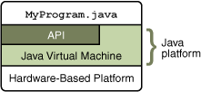

The API and Java Virtual Machine insulate the program from the underlying hardware.

Every full implementation of the Java platform gives you the following features:

* **Development Tools**: The development tools provide means for compiling, running, debugging, and documenting your applications. The main tools are the javac compiler, the java launcher, and the javadoc documentation tool.
* **Application Programming Interface (API)**: The API provides the core functionality of the Java programming language. It offers a wide array of useful classes ready for use in your own applications. It spans everything from basic objects, to networking and security, to XML generation and database access, etc.
* **Deployment Technologies**: The JDK software provides standard mechanisms such as the Java Web Start software and Java Plug-In software for deploying your applications to end users.
* **User Interface Toolkits**: The Swing and Java 2D toolkits make it possible to create sophisticated Graphical User Interfaces (GUIs).
* **Integration Libraries**: Integration libraries such as the Java IDL, JDBC, JNDI, Java RMI, and Java Remote Method Invocation over Internet Inter-ORB Protocol Technology (Java RMI-IIOP Technology) enable database access and manipulation of remote objects.

### *Java - Exception Handling*

An exception is an event, which occurs during the execution of a program that disrupts the normal flow of the program's instructions.

When an error occurs within a method, the method creates an object and hands it off to the runtime system. The object, called an exception object, contains information about the error, including its type and the state of the program when the error occurred. Creating an exception object and handing it to the runtime system is called throwing an exception.

After a method throws an exception, the runtime system attempts to find something to handle it. The set of possible "somethings" to handle the exception is the ordered list of methods that had been called to get to the method where the error occurred. The list of methods is known as the call stack (see the next figure).

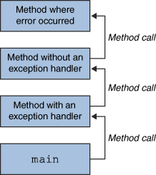

The call stack.

The runtime system searches the call stack for a method that contains a block of code that can handle the exception. This block of code is called an exception handler. The search begins with the method in which the error occurred and proceeds through the call stack in the reverse order in which the methods were called. When an appropriate handler is found, the runtime system passes the exception to the handler. An exception handler is considered appropriate if the type of the exception object thrown matches the type that can be handled by the handler.

The exception handler chosen is said to catch the exception. If the runtime system exhaustively searches all the methods on the call stack without finding an appropriate exception handler, as shown in the next figure, the runtime system (and, consequently, the program) terminates.

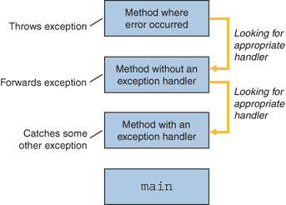

Searching the call stack for the exception handler.

Using exceptions to manage errors has following advantages over traditional error-management techniques:

Separating Error-Handling Code from "Regular" Code

Propagating Errors up the Call Stack

Grouping and Differentiating Error Types

A program can catch exceptions by using a combination of the try, catch, and finally blocks.

The try block identifies a block of code in which an exception can occur.

The catch block identifies a block of code, known as an exception handler that can handle a particular type of exception.

The finally block identifies a block of code that is guaranteed to execute, and is the right place to close files, recover resources, and otherwise clean up after the code enclosed in the try block.

### JDBC

JDBC stands for "Java Database Connectivity". It is an API (Application Programming Interface) which consists of a set of Java classes, interfaces and exceptions and a specification to which both JDBC driver vendors and JDBC developers adhere when developing applications.

JDBC is a very popular data access standard. RDBMS (Relational Database Management Systems) or third-party vendors develop drivers which adhere to the JDBC specification. Other developers use these drivers to develop applications which access those databases.

* ***JDBC Architecture***

The JDBC API supports both two-tier and three-tier processing models for database access.

***Figure 1: Two-tier Architecture for Data Access.***

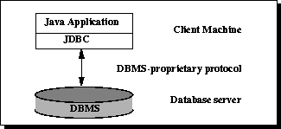

In the two-tier model, a Java application talks directly to the data source. This requires a JDBC driver that can communicate with the particular data source being accessed. A user's commands are delivered to the database or other data source, and the results of those statements are sent back to the user. The data source may be located on another machine to which the user is connected via a network. This is referred to as a client/server configuration, with the user's machine as the client, and the machine housing the data source as the server.

The JDBC API is a Java API that can access any kind of tabular data, especially data stored in a Relational Database.

JDBC helps you to write java applications that manage these three programming activities:

* Connect to a data source, like a database
* Send queries and update statements to the database
* Retrieve and process the results received from the database in answer to your query

In the three-tier model, commands are sent to a "middle tier" of services, which then sends the commands to the data source. The data source processes the commands and sends the results back to the middle tier, which then sends them to the user. MIS directors find the three-tier model very attractive because the middle tier makes it possible to maintain control over access and the kinds of updates that can be made to corporate data. Another advantage is that it simplifies the deployment of applications. Finally, in many cases, the three-tier architecture can provide performance advantages.

***Figure 2:Three tier architecture for data access***

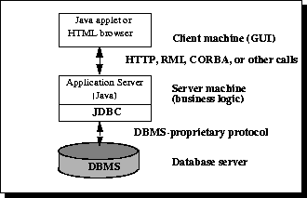

Until recently, the middle tier has often been written in languages such as C or C++, which offer fast performance. However, with the introduction of optimizing compilers that translate Java byte-code into efficient machine-specific code and technologies such as Enterprise JavaBeans, the Java platform is fast becoming the standard platform for middle-tier development. This is a big plus, making it possible to take advantage of Java's robustness, multithreading, and security features.

With enterprises increasingly using the Java programming language for writing server code, the JDBC API is being used more and more in the middle tier of a three-tier architecture. Some of the features that make JDBC a server technology are its support for connection pooling, distributed transactions, and disconnected rowsets. The JDBC API is also what allows access to a data source from a Java middle tier. Different database systems have surprisingly little in common: just a similar purpose and a mostly compatible query language. Beyond that, every database has its own API that you must learn to write programs that interact with the database. This has meant that writing code capable of interfacing with databases from more than one vendor has been a daunting challenge. Cross-database APIs exist, most notably Microsoft's ODBC API, but these tend to find themselves, at best, limited to a particular platform.

JDBC is Sun's attempt to create a platform-neutral interface between databases and Java. With JDBC, you can count on a standard set of database access features and (usually) a particular subset of SQL, SQL-92. The JDBC API defines a set of interfaces that encapsulate major database functionality, including running queries, processing results, and determining configuration information. A database vendor or third-party developer writes a JDBC *driver*, which is a set of classes that implements these interfaces for a particular database system. An application can use a number of drivers interchangeably. Following figure shows how an application uses JDBC to interact with one or more databases without knowing about the underlying driver implementations.

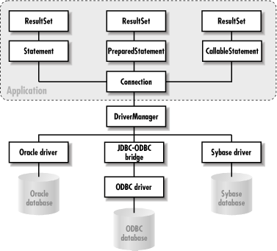

**Software used**

* **J2SE – Java 2 Standard Edition**

There are two principal products in the Java SE platform family:

1) Java SE Runtime Environment (JRE)

2) Java Development Kit (JDK).

The Java Runtime Environment (JRE) provides the libraries, the Java Virtual Machine, and other components to run applets and applications written in the Java programming language. In addition, two key deployment technologies are part of the JRE: Java Plug-in, which enables applets to run in popular browsers; and Java Web Start, which deploys standalone applications over a network. It is also the foundation for the technologies in the Java 2 Platform, Enterprise Edition (J2EE) for enterprise software development and deployment. The JRE does not contain tools and utilities such as compilers or debuggers for developing applets and applications.

The Java Development Kit (JDK) is a superset of the JRE, and contains everything that is in the JRE, plus tools such as the compilers and debuggers necessary for developing applets and applications.

* **Java SE API**

The Java SE application programming interface (API) defines the manner by which an applet or application can make requests to and use the functionality available in the compiled Java SE class libraries. (The Java SE class libraries are also part of the Java SE platform.)

The Java SE API consists of core technologies, Desktop (or client) technologies, and other technologies.

* Core components provide essential functionality for writing powerful enterprise-worthy programs in key areas such as database access, security, remote method invocation (RMI), and communications.
* Desktop components add a full range of features to help build applications that provide a rich user experience – deployment products such as Java Plug-in, component modeling APIs such as JavaBeans, and a graphical user interface.
* Other components round out the functionality.
* **Java Virtual Machine**

The Java Virtual Machine is responsible for the hardware- and operating system-independence of the Java SE platform, the small size of compiled code (byte-codes), and platform security.

* **Java Platform Tools**

The Java SE platform works with an array of tools, including Integrated Development Environments (IDEs), performance and testing tools, and performance monitoring tools.

* **Notepad++ :**

Notepad++ is a text editor and source code editor for Windows. It differs from Notepad, the built-in Windows text editor in that Notepad++ supports tabbed editing, which allows working with multiple open files in a single window. Notepad++ opens large files significantly faster than Windows Notepad. The project's name comes from the C increment operator.

Notepad++ is distributed as free software. The project was hosted on SourceForge.net, from where it has been downloaded over 28 million times and twice won the SourceForge Community Choice Award for Best Developer Tool. The project has been hosted on TuxFamily since June 2010. Notepad++ uses the Scintilla editor component.

**General features include:**

* Tabbed document interface.
* Drag-and-drop
* Multiple clipboards (plugin required)
* Split screen editing and synchronized scrolling
* Spell checker (requires Aspell) (Spell checker does not distinguish between text and code)
* Supports text encoding formats such as Unicode, for international writing systems. UTF-8 and several UTF-16 encodings are supported.
* Find and replace: with regular expressions (including multi-line); over multiple documents; and marking/summary of occurrences
* Data comparison
* Zooming

**Source code editing features include:**

* Auto-completion
* Bookmarks
* Syntax highlighting and syntax folding
* Brace and indent highlighting
* Smart highlighting
* Project manager
* Regular expression find and replace (in perl compatible extent)
* Speech synthesis
* FTP Browser (plug-in included in standard installation)
* Macro recording and execution.
* Various tools such as line sorting, text encoding conversion, text folding
* File status auto-detection
* Customizable shortcut key mapping.
* Function list.

Notepad++ also supports Unix line endings so that it can be used to work with texts that have been produced on (or will be moved to) machines that run Unix operating systems.

* **SQL SERVER 2012:**

Microsoft SQL Server 2012 is a database and data analysis platform for large-scale online transaction processing (OLTP), data warehousing, and e-commerce applications. It has following features.

|  |  |
| --- | --- |
|  | **Database Engine**  The Database Engine is the core service for storing, processing and securing data. The Database Engine provides controlled access and rapid transaction processing to meet the requirements of the most demanding data consuming applications within your enterprise. The Database Engine also provides rich support for sustaining high availability. |
| Analysis Services icon | **Analysis Services**  Analysis Services delivers online analytical processing (OLAP) and data mining functionality for business intelligence applications. Analysis Services supports OLAP by allowing you to design, create, and manage multidimensional structures that contain data aggregated from other data sources, such as relational databases. For data mining applications, Analysis Services enables you to design, create, and visualize data mining models. These mining models can be constructed from other data sources by using a wide variety of industry-standard data mining algorithms. |
| Integration Services icon | **Integration Services**  Integration Services is a platform for building high performance data integration solutions, including packages that provide extract, transform, and load (ETL) processing for data warehousing. |
| Replication icon | **Replication**  Replication is a set of technologies for copying and distributing data and database objects from one database to another, and then synchronizing between databases to maintain consistency. By using replication, you can distribute data to different locations and to remote or mobile users by means of local and wide area networks, dial-up connections, wireless connections, and the Internet. |
| Reporting Services icon | **Reporting Services**  Reporting Services delivers enterprise, Web-enabled reporting functionality so you can create reports that draw content from a variety of data sources, publish reports in various formats, and centrally manage security and subscriptions. |
| Notification Services icon | **Notification Services**  Notification Services is an environment for developing and deploying applications that generate and send notifications. You can use Notification Services to generate and send timely, personalized messages to thousands or millions of subscribers, and can deliver the messages to a variety of devices. |
| Service Broker icon | **Service Broker**  Service Broker helps developers build scalable, secure database applications. This new Database Engine technology provides a message-based communication platform that enables independent application components to perform as a functioning whole. Service Broker includes infrastructure for asynchronous programming that can be used for applications within a single database or a single instance, and also for distributed applications. |
| Full Text icon | **Full-Text Search**  Full-Text Search contains the functionality you can use to issue full-text queries against plain character-based data in SQL Server tables. Full-text queries can include words and phrases, or multiple forms of a word or phrase. |

* **Details of Project:**

This Project will cover the following Modules:-

**ADMIN:**

**a. Add User:** This module will help to add user in the database.

**b. Remove User:**This module will help to delete the user from database.

**c. Change Password**: This module will help to change the password of any existing user.

**MASTER:**

**a.Course:**It records the courses offered in the organization.

**b.Student:**It maintains the records of the student data in the database.

**c.Club:**Itmaintains the records of all the clubs and used to form new ones.

**PROCESS:**

**a. Membership form:**This form will be used to add new members and view or update information of pre-existing members.

**b. Event form:**This form will be used to maintain records of all the events organized by the clubs.

**c. Participants form:**This form will be used to add, view and updateparticipants in database.

**d. Volunteers form:**This form will be used to add, view and update volunteers in database.

**REPORT:**

**a. Member Report:**It shows the stats of the various members.

**b. Event Report:**It generates the report of the events.

**c.Volunteer Report:**It shows the stats of the volunteers.

**d.ParticipantReport:**It shows the stats of the participants.

**Application Screenshots**

**Admin Login**

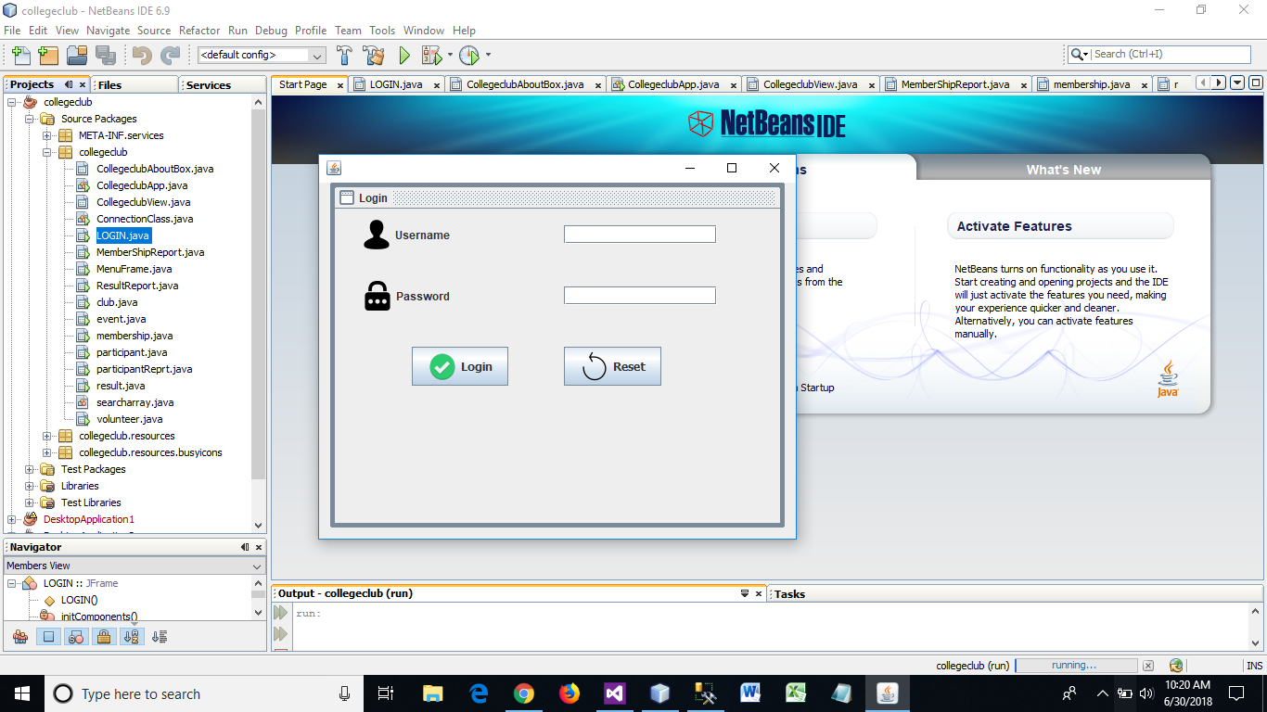

**Home**

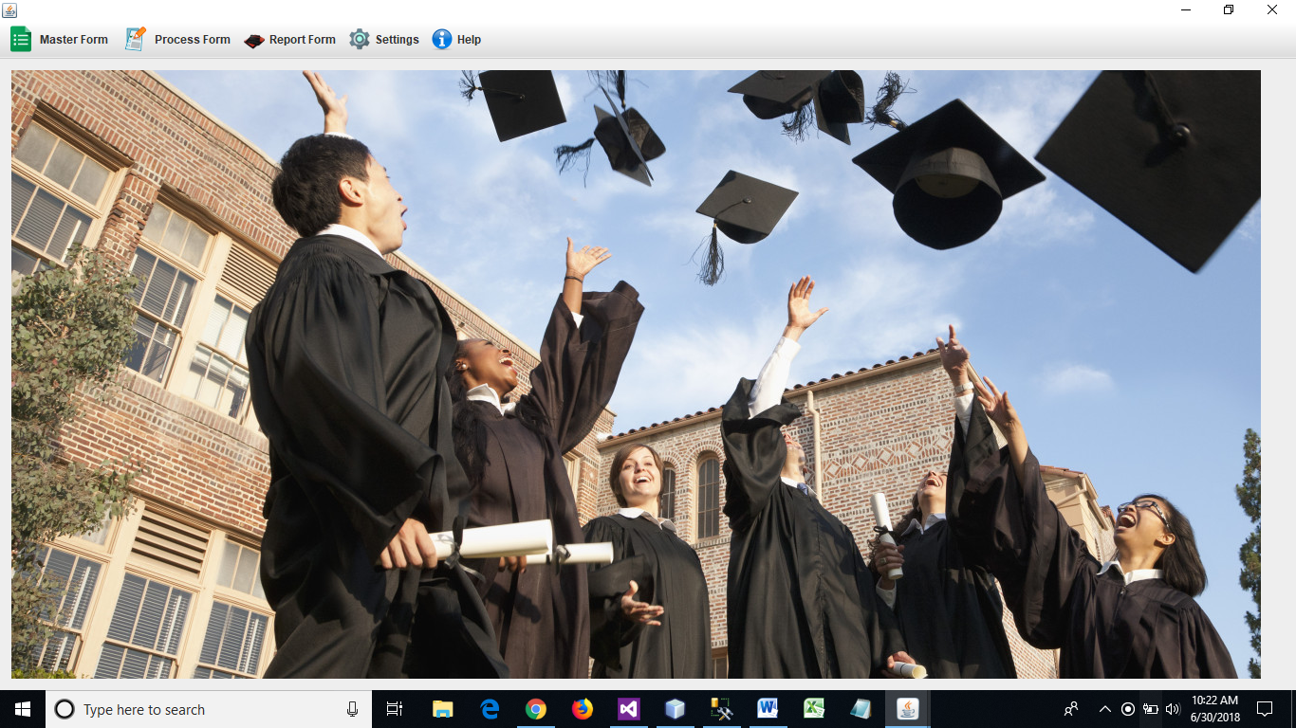

**Master Form – Club**

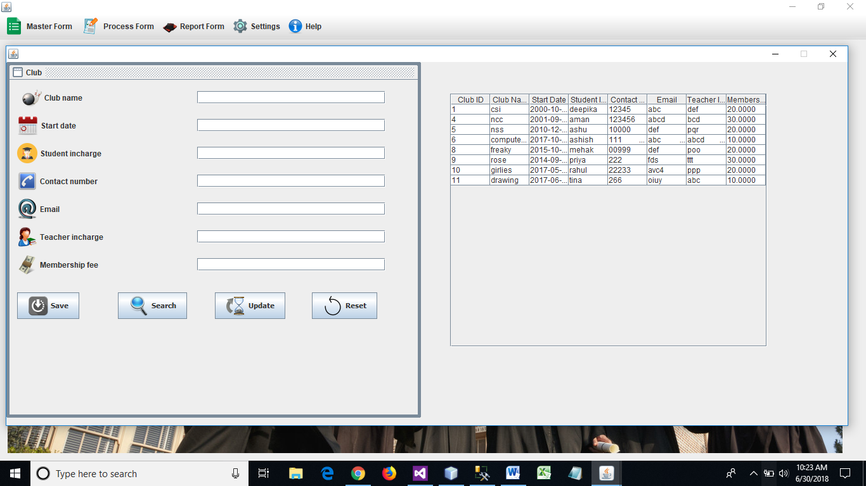

**Master Form – Event**

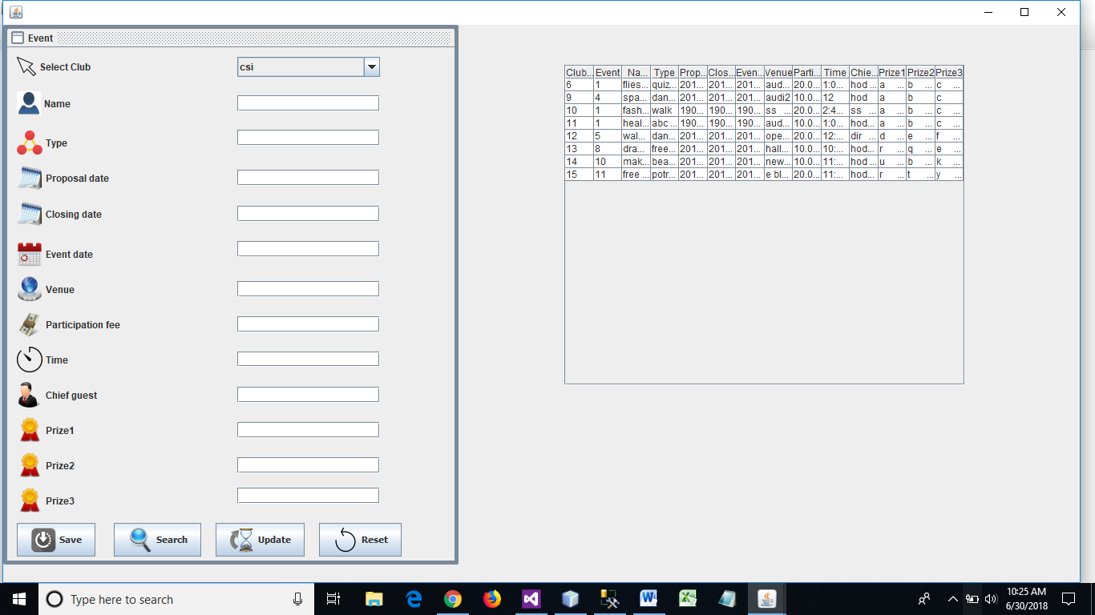

**Process Form – Membership**

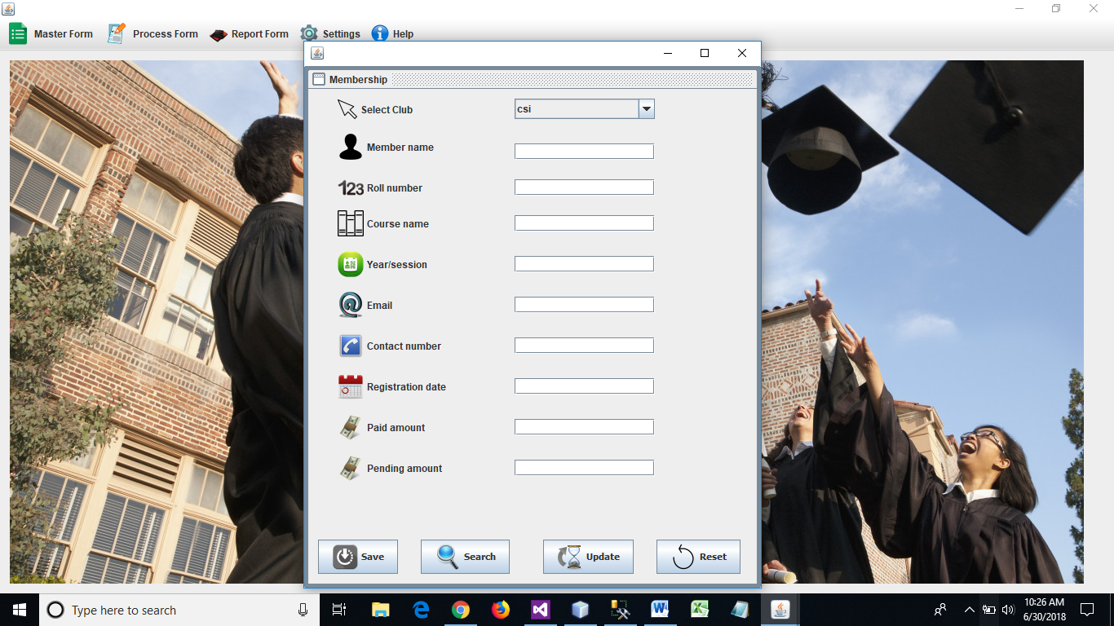

**Process Form - Participant**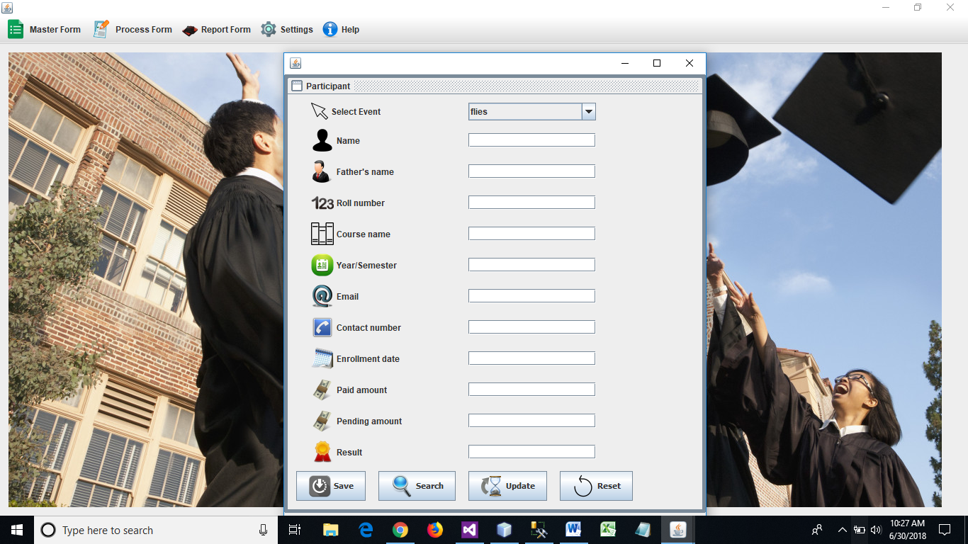

**Process Form – Volunteer**

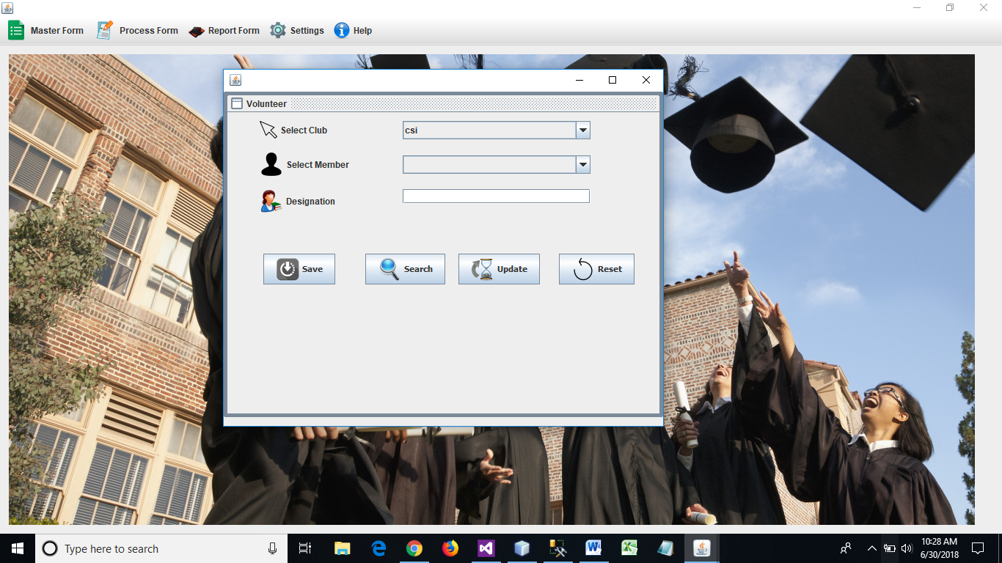

**Process Form – Result**

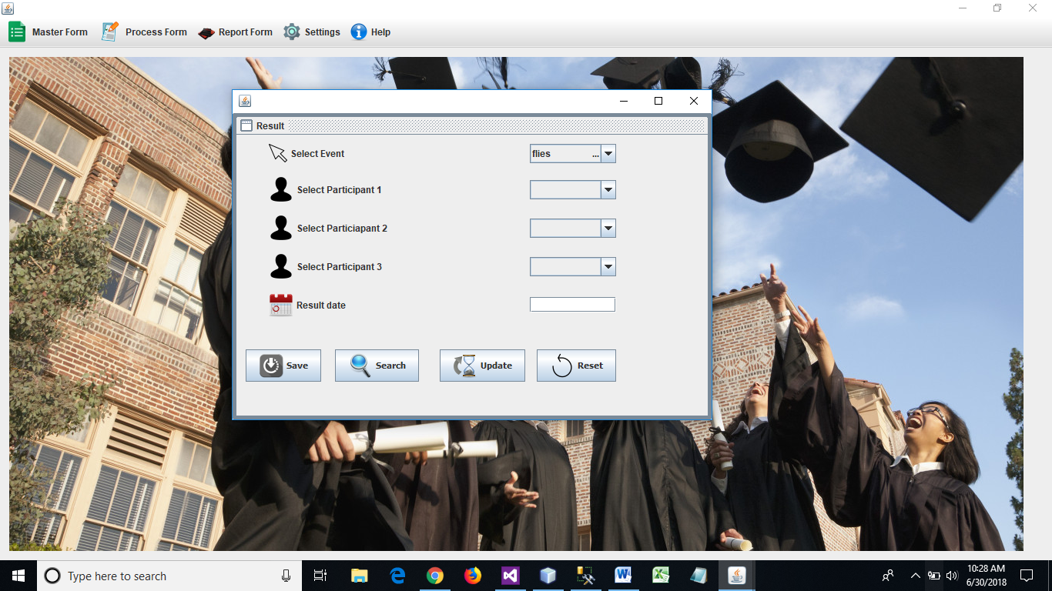

**Report Form – Membership Report**

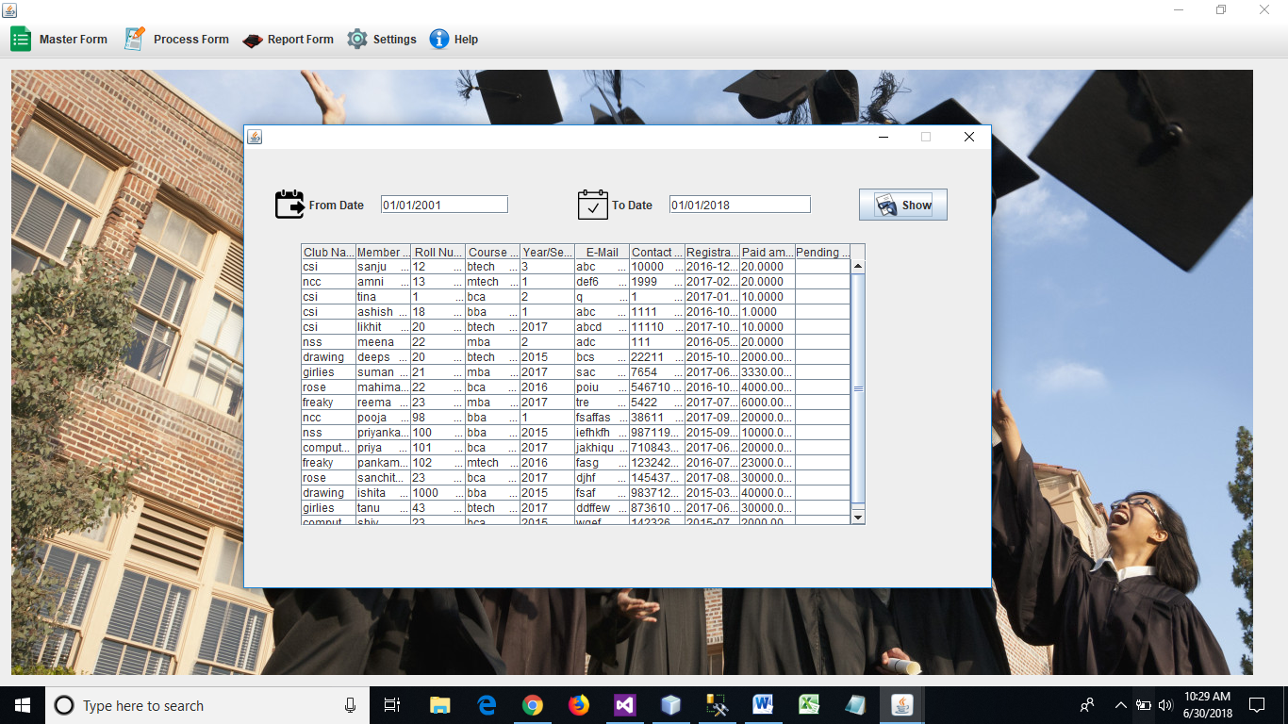

**Report Form – Participant Report**

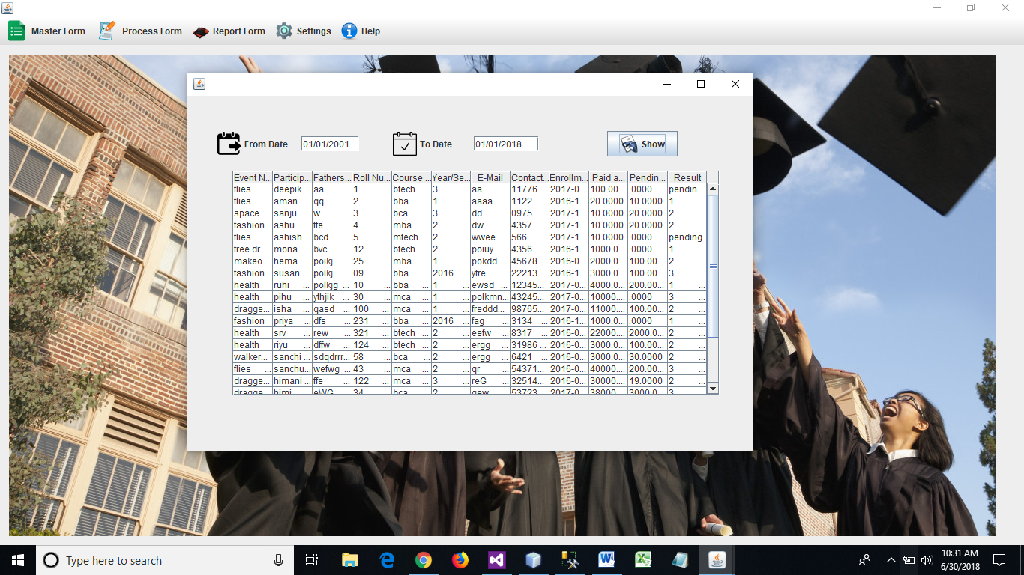

**Report Form – Result Report**

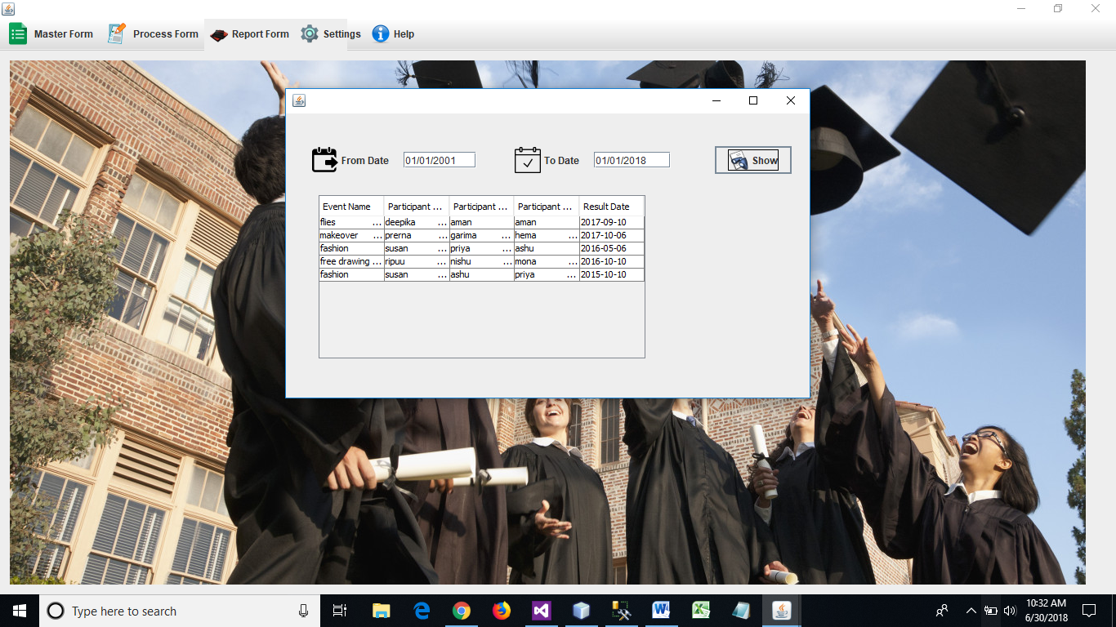

**Database**

**Table – Club**

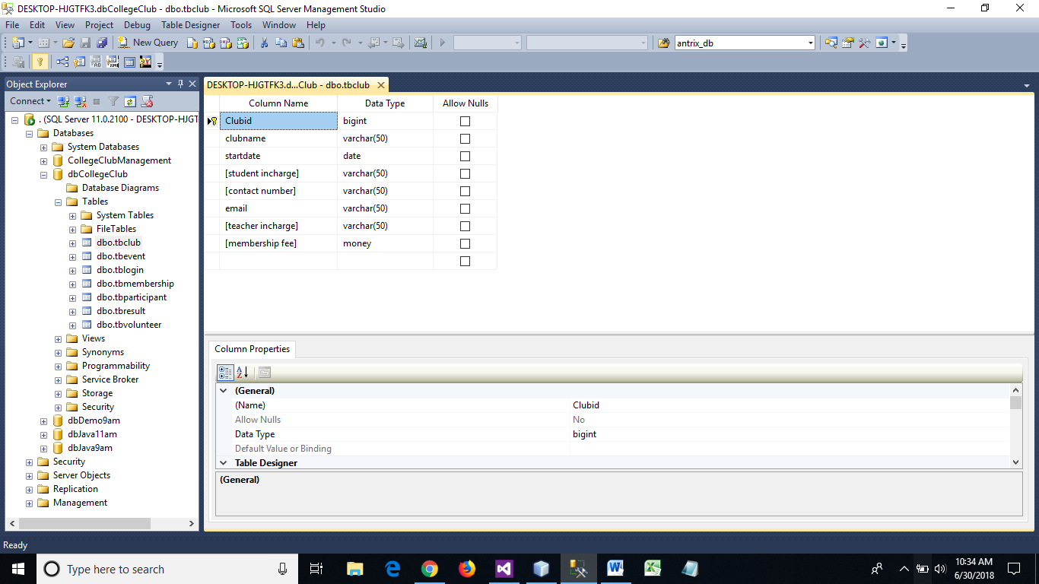

**Table – Event**

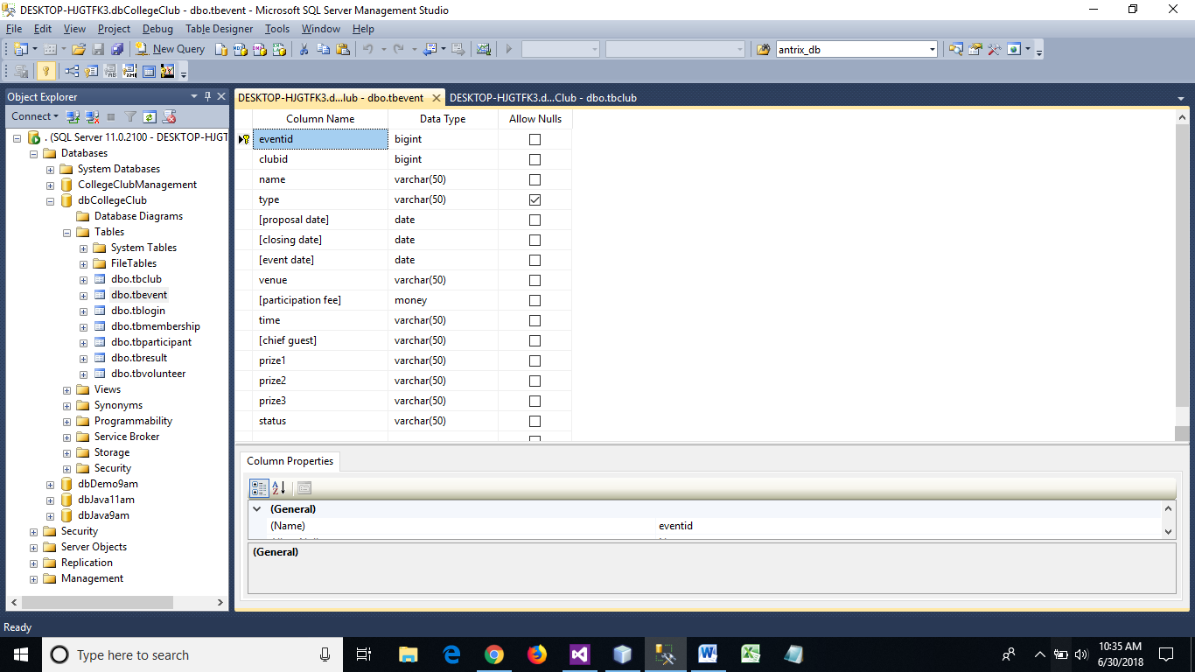

**Table – Login**

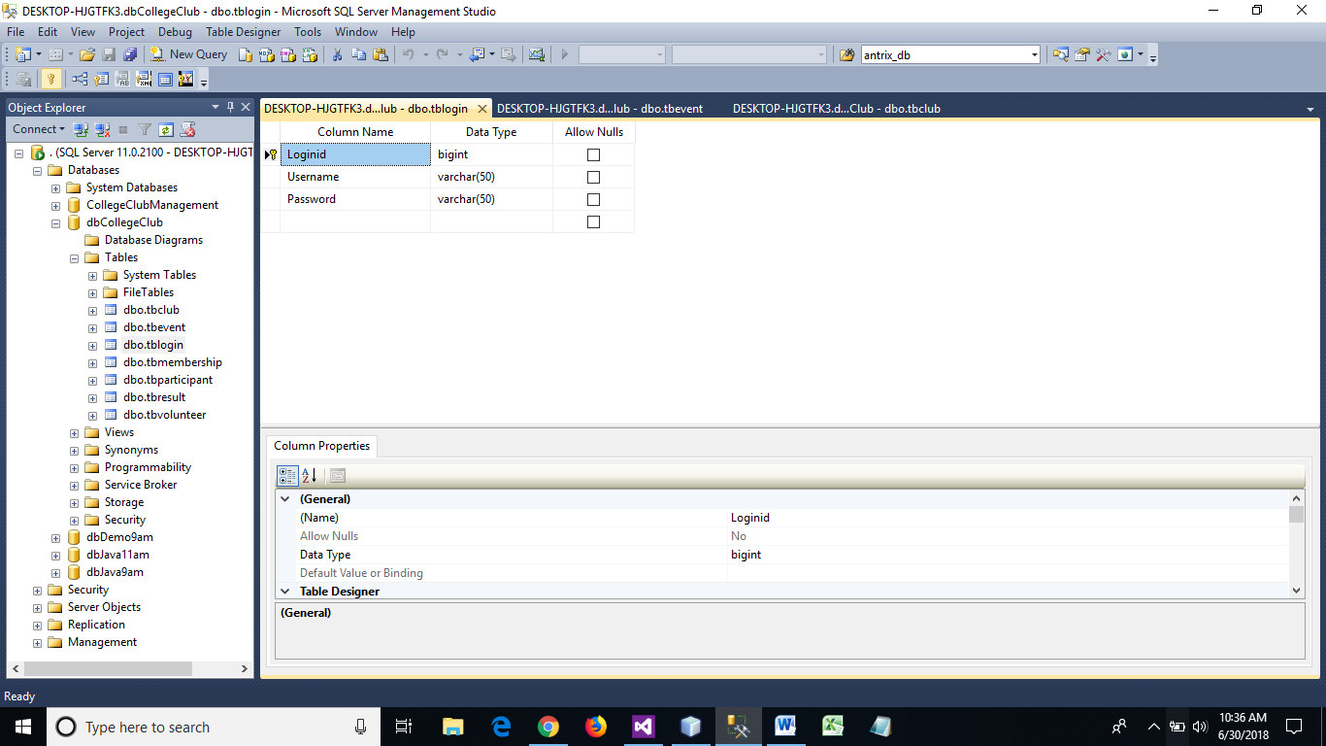

**Table – Membership**

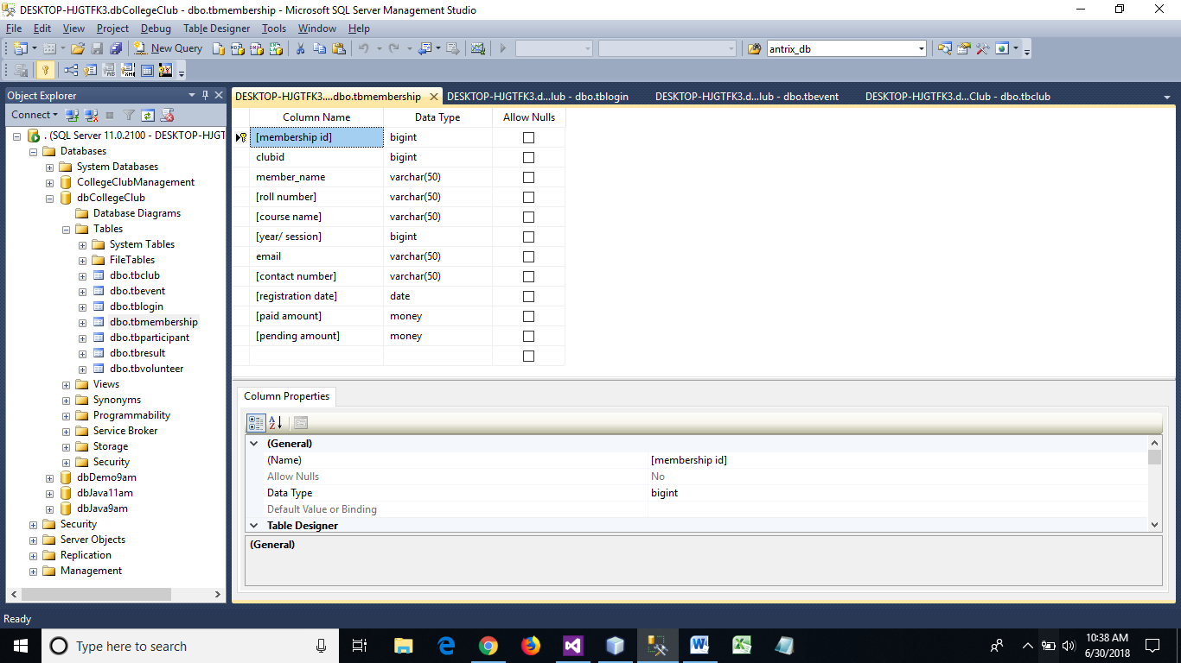

**Table – Participant**

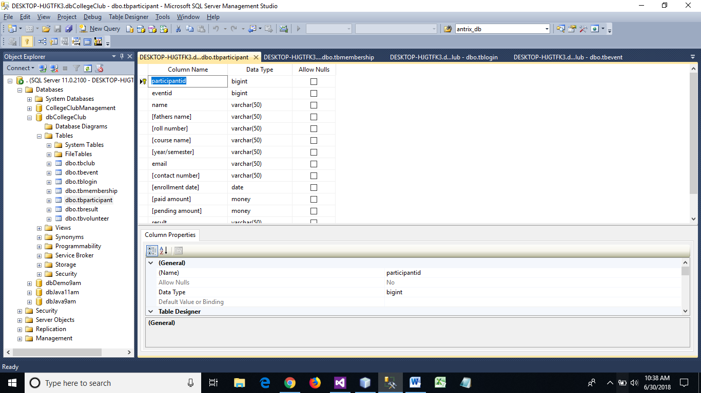

**Table –Result**



**Table – Volunteer**

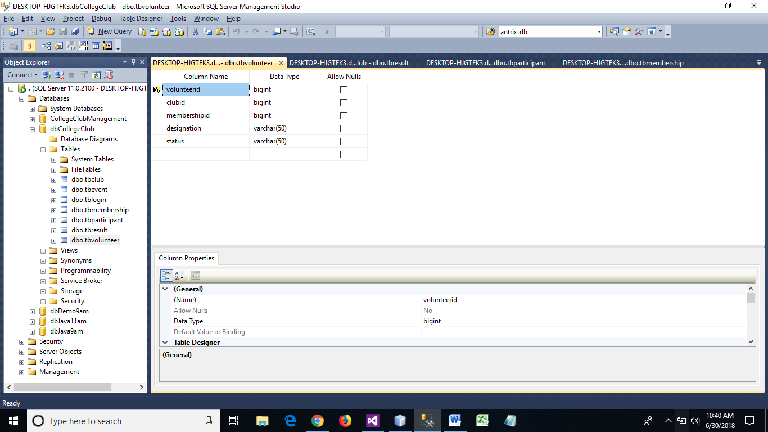

**Coding**

**Admin Login**

**package collegeclub;**

**import javax.swing.JOptionPane;**

**/\*\***

**\***

**\* @author HP**

**\*/**

**public class LOGIN extends javax.swing.JFrame {**

**/** Creates new form LOGIN */**

**public LOGIN() {**

**initComponents();**

**}**

**int attempts=1;**

**/** This method is called from within the constructor to**

**\* initialize the form.**

**\* WARNING: Do NOT modify this code. The content of this method is**

**\* always regenerated by the Form Editor.**

**\*/**

**@SuppressWarnings("unchecked")**

**// <editor-fold defaultstate="collapsed" desc="Generated Code">**

**private void initComponents() {**

**jInternalFrame1 = new javax.swing.JInternalFrame();**

**jPasswordField1 = new javax.swing.JPasswordField();**

**usernamejLabel1 = new javax.swing.JLabel();**

**jLabel3 = new javax.swing.JLabel();**

**loginjButton1 = new javax.swing.JButton();**

**psswordjLabel2 = new javax.swing.JLabel();**

**userjTextField1 = new javax.swing.JTextField();**

**jButton1 = new javax.swing.JButton();**

**setDefaultCloseOperation(javax.swing.WindowConstants.EXIT_ON_CLOSE);**

**jInternalFrame1.setTitle("Login");**

**jInternalFrame1.setVisible(true);**

**usernamejLabel1.setIcon(new javax.swing.ImageIcon(getClass().getResource("/collegeclub/resources/Users-Name-icon (1).png"))); // NOI18N**

**usernamejLabel1.setText("Username");**

**loginjButton1.setFont(new java.awt.Font("Tahoma", 1, 12));**

**loginjButton1.setIcon(new javax.swing.ImageIcon(getClass().getResource("/collegeclub/resources/sign-check-icon (1).png"))); // NOI18N**

**loginjButton1.setText("Login");**

**loginjButton1.addActionListener(new java.awt.event.ActionListener() {**

**public void actionPerformed(java.awt.event.ActionEvent evt) {**

**loginjButton1ActionPerformed(evt);**

**}**

**});**

**psswordjLabel2.setIcon(new javax.swing.ImageIcon(getClass().getResource("/collegeclub/resources/Security-Password-2-icon.png"))); // NOI18N**

**psswordjLabel2.setText("Password");**

**jButton1.setFont(new java.awt.Font("Tahoma", 1, 12));**

**jButton1.setIcon(new javax.swing.ImageIcon(getClass().getResource("/collegeclub/resources/reset.png"))); // NOI18N**

**jButton1.setText("Reset");**

**jButton1.addActionListener(new java.awt.event.ActionListener() {**

**public void actionPerformed(java.awt.event.ActionEvent evt) {**

**jButton1ActionPerformed(evt);**

**}**

**});**

**org.jdesktop.layout.GroupLayout jInternalFrame1Layout = new org.jdesktop.layout.GroupLayout(jInternalFrame1.getContentPane());**

**jInternalFrame1.getContentPane().setLayout(jInternalFrame1Layout);**

**jInternalFrame1Layout.setHorizontalGroup(**

**jInternalFrame1Layout.createParallelGroup(org.jdesktop.layout.GroupLayout.LEADING)**

**.add(jInternalFrame1Layout.createSequentialGroup()**

**.add(jInternalFrame1Layout.createParallelGroup(org.jdesktop.layout.GroupLayout.LEADING)**

**.add(jInternalFrame1Layout.createSequentialGroup()**

**.add(jInternalFrame1Layout.createParallelGroup(org.jdesktop.layout.GroupLayout.LEADING)**

**.add(jInternalFrame1Layout.createSequentialGroup()**

**.add(29, 29, 29)**

**.add(jInternalFrame1Layout.createParallelGroup(org.jdesktop.layout.GroupLayout.LEADING)**

**.add(org.jdesktop.layout.GroupLayout.TRAILING, psswordjLabel2)**

**.add(org.jdesktop.layout.GroupLayout.TRAILING, usernamejLabel1))**

**.add(74, 74, 74))**

**.add(org.jdesktop.layout.GroupLayout.TRAILING, jInternalFrame1Layout.createSequentialGroup()**

**.addContainerGap(83, Short.MAX_VALUE)**

**.add(loginjButton1)**

**.add(60, 60, 60)))**

**.add(jInternalFrame1Layout.createParallelGroup(org.jdesktop.layout.GroupLayout.LEADING)**

**.add(jButton1)**

**.add(jInternalFrame1Layout.createParallelGroup(org.jdesktop.layout.GroupLayout.LEADING, false)**

**.add(jPasswordField1)**

**.add(userjTextField1, org.jdesktop.layout.GroupLayout.DEFAULT_SIZE, 165, Short.MAX_VALUE))))**

**.add(jInternalFrame1Layout.createSequentialGroup()**

**.add(70, 70, 70)**

**.add(jLabel3, org.jdesktop.layout.GroupLayout.PREFERRED_SIZE, 238, org.jdesktop.layout.GroupLayout.PREFERRED_SIZE)))**

**.addContainerGap(68, Short.MAX_VALUE))**

**);**

**jInternalFrame1Layout.setVerticalGroup(**

**jInternalFrame1Layout.createParallelGroup(org.jdesktop.layout.GroupLayout.LEADING)**

**.add(jInternalFrame1Layout.createSequentialGroup()**

**.addContainerGap()**

**.add(jInternalFrame1Layout.createParallelGroup(org.jdesktop.layout.GroupLayout.BASELINE)**

**.add(userjTextField1, org.jdesktop.layout.GroupLayout.PREFERRED_SIZE, org.jdesktop.layout.GroupLayout.DEFAULT_SIZE, org.jdesktop.layout.GroupLayout.PREFERRED_SIZE)**

**.add(usernamejLabel1))**

**.add(34, 34, 34)**

**.add(jInternalFrame1Layout.createParallelGroup(org.jdesktop.layout.GroupLayout.BASELINE)**

**.add(psswordjLabel2)**

**.add(jPasswordField1, org.jdesktop.layout.GroupLayout.PREFERRED_SIZE, org.jdesktop.layout.GroupLayout.DEFAULT_SIZE, org.jdesktop.layout.GroupLayout.PREFERRED_SIZE))**

**.add(39, 39, 39)**

**.add(jInternalFrame1Layout.createParallelGroup(org.jdesktop.layout.GroupLayout.BASELINE)**

**.add(jButton1)**

**.add(loginjButton1))**

**.add(45, 45, 45)**

**.add(jLabel3, org.jdesktop.layout.GroupLayout.PREFERRED_SIZE, 19, org.jdesktop.layout.GroupLayout.PREFERRED_SIZE)**

**.addContainerGap(84, Short.MAX_VALUE))**

**);**

**org.jdesktop.layout.GroupLayout layout = new org.jdesktop.layout.GroupLayout(getContentPane());**

**getContentPane().setLayout(layout);**

**layout.setHorizontalGroup(**

**layout.createParallelGroup(org.jdesktop.layout.GroupLayout.LEADING)**

**.add(layout.createSequentialGroup()**

**.addContainerGap()**

**.add(jInternalFrame1)**

**.addContainerGap())**

**);**

**layout.setVerticalGroup(**

**layout.createParallelGroup(org.jdesktop.layout.GroupLayout.LEADING)**

**.add(org.jdesktop.layout.GroupLayout.TRAILING, layout.createSequentialGroup()**

**.add(jInternalFrame1)**

**.addContainerGap())**

**);**

**pack();**

**}// </editor-fold>**

**private void loginjButton1ActionPerformed(java.awt.event.ActionEvent evt) {**

**if(userjTextField1.getText().equals("admin")&&jPasswordField1.getText().equals("admin")){**

**jLabel3.setText("Access Granted !! ");**

**MenuFrame obj = new MenuFrame();**

**obj.setVisible(true);**

**}**

**else if ( attempts==3&&userjTextField1.getText()!="admin"&&jPasswordField1.getText()!="admin" ){**

**jLabel3.setText("Access Denied !!");**

**JOptionPane.showMessageDialog(null, "number of attempts exceeded"+attempts);**

**System.exit(0);**

**}else{**

**JOptionPane.showMessageDialog(null,"Number of attempts " +attempts);**

**attempts++;**

**userjTextField1.setText("");**

**jPasswordField1.setText("");**

**}**

**}**

**private void jButton1ActionPerformed(java.awt.event.ActionEvent evt) {**

**userjTextField1.setText("");**

**jPasswordField1.setText("");**

**}**

**/\*\***

**\* @param args the command line arguments**

**\*/**

**public static void main(String args[]) {**

**java.awt.EventQueue.invokeLater(new Runnable() {**

**public void run() {**

**new LOGIN().setVisible(true);**

**}**

**});**

**}**

**// Variables declaration - do not modify**

**private javax.swing.JButton jButton1;**

**private javax.swing.JInternalFrame jInternalFrame1;**

**private javax.swing.JLabel jLabel3;**

**private javax.swing.JPasswordField jPasswordField1;**

**private javax.swing.JButton loginjButton1;**

**private javax.swing.JLabel psswordjLabel2;**

**private javax.swing.JTextField userjTextField1;**

**private javax.swing.JLabel usernamejLabel1;**

**// End of variables declaration**

**}**

**Club**

**package collegeclub;**

**import java.sql.*;**

**import javax.swing.*;**

**import javax.swing.table.DefaultTableModel;**

**/\*\***

**\***

**\* @author HP**

**\*/**

**public class club extends javax.swing.JFrame {**

**ConnectionClass cobj;**

**PreparedStatement pst;**

**ResultSet rst;**

**Long clubid;**

**DefaultTableModel model;**

**JTable table;**

**JScrollPane js;**

**/** Creates new form club */**

**public club() {**

**initComponents();**

**cobj=new ConnectionClass();**

**model = new DefaultTableModel();**

**table = new JTable(model);**

**js = new JScrollPane(table);**

**model.addColumn("Club ID");**

**model.addColumn("Club Name");**

**model.addColumn("Start Date");**

**model.addColumn("Student Incharge");**

**model.addColumn("Contact Number");**

**model.addColumn("Email");**

**model.addColumn("Teacher Incharge");**

**model.addColumn("Membership Fee");**

**js.setBounds(700,50,500,400);**

**add(js);**

**cobj.Connect();**

**try**

**{**

**pst=cobj.con.prepareStatement("select * from tbClub");**

**rst=pst.executeQuery();**

**while(rst.next())**

**{**

**model.insertRow(model.getRowCount(), new Object[] { rst.getString(1),rst.getString(2),rst.getString(3),rst.getString(4),rst.getString(5),rst.getString(6),rst.getString(7),rst.getString(8)});**

**}**

**rst.close();**

**}**

**catch(Exception e)**

**{**

**System.out.println("error "+ e.getMessage());**

**}**

**cobj.DisConnect();**

**}**

**/** This method is called from within the constructor to**

**\* initialize the form.**

**\* WARNING: Do NOT modify this code. The content of this method is**

**\* always regenerated by the Form Editor.**

**\*/**

**@SuppressWarnings("unchecked")**

**// <editor-fold defaultstate="collapsed" desc="Generated Code">**

**private void initComponents() {**

**jScrollPane1 = new javax.swing.JScrollPane();**

**jTextArea1 = new javax.swing.JTextArea();**

**jInternalFrame1 = new javax.swing.JInternalFrame();**

**jlabel2 = new javax.swing.JLabel();**

**updatejButton = new javax.swing.JButton();**

**jTextField5 = new javax.swing.JTextField();**

**savejButton = new javax.swing.JButton();**

**jLabel6 = new javax.swing.JLabel();**

**jTextField4 = new javax.swing.JTextField();**

**jLabel8 = new javax.swing.JLabel();**

**jTextField2 = new javax.swing.JTextField();**

**jTextField3 = new javax.swing.JTextField();**

**jTextField6 = new javax.swing.JTextField();**

**jTextField8 = new javax.swing.JTextField();**

**searchjButton = new javax.swing.JButton();**

**jLabel5 = new javax.swing.JLabel();**

**jLabel3 = new javax.swing.JLabel();**

**jLabel4 = new javax.swing.JLabel();**

**jLabel7 = new javax.swing.JLabel();**

**resetjbutton = new javax.swing.JButton();**

**jTextField7 = new javax.swing.JTextField();**

**jTextArea1.setColumns(20);**

**jTextArea1.setRows(5);**

**jScrollPane1.setViewportView(jTextArea1);**

**setDefaultCloseOperation(javax.swing.WindowConstants.EXIT_ON_CLOSE);**

**setResizable(false);**

**jInternalFrame1.setTitle("Club");**

**jInternalFrame1.setVisible(true);**

**jlabel2.setIcon(new javax.swing.ImageIcon(getClass().getResource("/collegeclub/resources/Bowling-icon.png"))); // NOI18N**

**jlabel2.setText("Club name");**

**updatejButton.setFont(new java.awt.Font("Tahoma", 1, 11)); // NOI18N**

**updatejButton.setIcon(new javax.swing.ImageIcon(getClass().getResource("/collegeclub/resources/update.png"))); // NOI18N**

**updatejButton.setText("Update");**

**updatejButton.addActionListener(new java.awt.event.ActionListener() {**

**public void actionPerformed(java.awt.event.ActionEvent evt) {**

**updatejButtonActionPerformed(evt);**

**}**

**});**

**savejButton.setFont(new java.awt.Font("Tahoma", 1, 11)); // NOI18N**

**savejButton.setIcon(new javax.swing.ImageIcon(getClass().getResource("/collegeclub/resources/Apps-File-Save-B-icon.png"))); // NOI18N**

**savejButton.setText("Save");**

**savejButton.addActionListener(new java.awt.event.ActionListener() {**

**public void actionPerformed(java.awt.event.ActionEvent evt) {**

**savejButtonActionPerformed(evt);**

**}**

**});**

**jLabel6.setIcon(new javax.swing.ImageIcon(getClass().getResource("/collegeclub/resources/Mail-icon.png"))); // NOI18N**

**jLabel6.setText("Email");**

**jLabel8.setIcon(new javax.swing.ImageIcon(getClass().getResource("/collegeclub/resources/money-icon.png"))); // NOI18N**

**jLabel8.setText("Membership fee");**

**jTextField3.addActionListener(new java.awt.event.ActionListener() {**

**public void actionPerformed(java.awt.event.ActionEvent evt) {**

**jTextField3ActionPerformed(evt);**

**}**

**});**

**jTextField8.addActionListener(new java.awt.event.ActionListener() {**

**public void actionPerformed(java.awt.event.ActionEvent evt) {**

**jTextField8ActionPerformed(evt);**

**}**

**});**

**searchjButton.setFont(new java.awt.Font("Tahoma", 1, 11)); // NOI18N**

**searchjButton.setIcon(new javax.swing.ImageIcon(getClass().getResource("/collegeclub/resources/Search-icon.png"))); // NOI18N**

**searchjButton.setText("Search");**

**searchjButton.addActionListener(new java.awt.event.ActionListener() {**

**public void actionPerformed(java.awt.event.ActionEvent evt) {**

**searchjButtonActionPerformed(evt);**

**}**

**});**

**jLabel5.setIcon(new javax.swing.ImageIcon(getClass().getResource("/collegeclub/resources/Phone-icon.png"))); // NOI18N**

**jLabel5.setText("Contact number");**

**jLabel3.setIcon(new javax.swing.ImageIcon(getClass().getResource("/collegeclub/resources/Calendar-icon.png"))); // NOI18N**

**jLabel3.setText("Start date");**

**jLabel4.setIcon(new javax.swing.ImageIcon(getClass().getResource("/collegeclub/resources/Student-3-icon.png"))); // NOI18N**

**jLabel4.setText("Student incharge");**

**jLabel7.setIcon(new javax.swing.ImageIcon(getClass().getResource("/collegeclub/resources/Teacher-icon.png"))); // NOI18N**

**jLabel7.setText("Teacher incharge");**

**resetjbutton.setFont(new java.awt.Font("Tahoma", 1, 11)); // NOI18N**

**resetjbutton.setIcon(new javax.swing.ImageIcon(getClass().getResource("/collegeclub/resources/reset.png"))); // NOI18N**

**resetjbutton.setText("Reset");**

**resetjbutton.addActionListener(new java.awt.event.ActionListener() {**

**public void actionPerformed(java.awt.event.ActionEvent evt) {**

**resetjbuttonActionPerformed(evt);**

**}**

**});**

**org.jdesktop.layout.GroupLayout jInternalFrame1Layout = new org.jdesktop.layout.GroupLayout(jInternalFrame1.getContentPane());**

**jInternalFrame1.getContentPane().setLayout(jInternalFrame1Layout);**

**jInternalFrame1Layout.setHorizontalGroup(**

**jInternalFrame1Layout.createParallelGroup(org.jdesktop.layout.GroupLayout.LEADING)**

**.add(jInternalFrame1Layout.createSequentialGroup()**

**.add(jInternalFrame1Layout.createParallelGroup(org.jdesktop.layout.GroupLayout.LEADING)**

**.add(jInternalFrame1Layout.createSequentialGroup()**

**.addContainerGap()**

**.add(jInternalFrame1Layout.createParallelGroup(org.jdesktop.layout.GroupLayout.LEADING)**

**.add(jLabel4)**

**.add(jInternalFrame1Layout.createSequentialGroup()**

**.add(1, 1, 1)**

**.add(jLabel3))**

**.add(jLabel5)**

**.add(jLabel6)**

**.add(jLabel7)**

**.add(jLabel8)**

**.add(savejButton)))**

**.add(jInternalFrame1Layout.createSequentialGroup()**

**.add(19, 19, 19)**

**.add(jlabel2)))**

**.add(jInternalFrame1Layout.createParallelGroup(org.jdesktop.layout.GroupLayout.LEADING)**

**.add(jInternalFrame1Layout.createSequentialGroup()**

**.add(23, 23, 23)**

**.add(searchjButton)**

**.add(44, 44, 44)**

**.add(updatejButton)**

**.addPreferredGap(org.jdesktop.layout.LayoutStyle.RELATED, 42, Short.MAX_VALUE)**

**.add(resetjbutton)**

**.add(13, 13, 13))**

**.add(jInternalFrame1Layout.createSequentialGroup()**

**.add(148, 148, 148)**

**.add(jInternalFrame1Layout.createParallelGroup(org.jdesktop.layout.GroupLayout.LEADING)**

**.add(jTextField4, org.jdesktop.layout.GroupLayout.DEFAULT_SIZE, 291, Short.MAX_VALUE)**

**.add(jTextField5, org.jdesktop.layout.GroupLayout.DEFAULT_SIZE, 291, Short.MAX_VALUE)**

**.add(jTextField6, org.jdesktop.layout.GroupLayout.DEFAULT_SIZE, 291, Short.MAX_VALUE)**

**.add(jTextField7, org.jdesktop.layout.GroupLayout.DEFAULT_SIZE, 291, Short.MAX_VALUE)**

**.add(jTextField8, org.jdesktop.layout.GroupLayout.DEFAULT_SIZE, 291, Short.MAX_VALUE)**

**.add(jTextField3, org.jdesktop.layout.GroupLayout.DEFAULT_SIZE, 291, Short.MAX_VALUE)**

**.add(jTextField2, org.jdesktop.layout.GroupLayout.DEFAULT_SIZE, 291, Short.MAX_VALUE))))**

**.add(51, 51, 51))**

**);**

**jInternalFrame1Layout.setVerticalGroup(**

**jInternalFrame1Layout.createParallelGroup(org.jdesktop.layout.GroupLayout.LEADING)**

**.add(jInternalFrame1Layout.createSequentialGroup()**

**.addContainerGap()**

**.add(jInternalFrame1Layout.createParallelGroup(org.jdesktop.layout.GroupLayout.BASELINE)**

**.add(jTextField2, org.jdesktop.layout.GroupLayout.PREFERRED_SIZE, org.jdesktop.layout.GroupLayout.DEFAULT_SIZE, org.jdesktop.layout.GroupLayout.PREFERRED_SIZE)**

**.add(jlabel2))**

**.addPreferredGap(org.jdesktop.layout.LayoutStyle.UNRELATED)**

**.add(jInternalFrame1Layout.createParallelGroup(org.jdesktop.layout.GroupLayout.BASELINE)**

**.add(jLabel3)**

**.add(jTextField3, org.jdesktop.layout.GroupLayout.PREFERRED_SIZE, org.jdesktop.layout.GroupLayout.DEFAULT_SIZE, org.jdesktop.layout.GroupLayout.PREFERRED_SIZE))**

**.addPreferredGap(org.jdesktop.layout.LayoutStyle.UNRELATED)**

**.add(jInternalFrame1Layout.createParallelGroup(org.jdesktop.layout.GroupLayout.BASELINE)**

**.add(jLabel4)**

**.add(jTextField4, org.jdesktop.layout.GroupLayout.PREFERRED_SIZE, org.jdesktop.layout.GroupLayout.DEFAULT_SIZE, org.jdesktop.layout.GroupLayout.PREFERRED_SIZE))**

**.addPreferredGap(org.jdesktop.layout.LayoutStyle.UNRELATED)**

**.add(jInternalFrame1Layout.createParallelGroup(org.jdesktop.layout.GroupLayout.BASELINE)**

**.add(jLabel5)**

**.add(jTextField5, org.jdesktop.layout.GroupLayout.PREFERRED_SIZE, org.jdesktop.layout.GroupLayout.DEFAULT_SIZE, org.jdesktop.layout.GroupLayout.PREFERRED_SIZE))**

**.addPreferredGap(org.jdesktop.layout.LayoutStyle.UNRELATED)**

**.add(jInternalFrame1Layout.createParallelGroup(org.jdesktop.layout.GroupLayout.BASELINE)**

**.add(jLabel6)**

**.add(jTextField6, org.jdesktop.layout.GroupLayout.PREFERRED_SIZE, org.jdesktop.layout.GroupLayout.DEFAULT_SIZE, org.jdesktop.layout.GroupLayout.PREFERRED_SIZE))**

**.addPreferredGap(org.jdesktop.layout.LayoutStyle.UNRELATED)**

**.add(jInternalFrame1Layout.createParallelGroup(org.jdesktop.layout.GroupLayout.BASELINE)**

**.add(jLabel7)**

**.add(jTextField7, org.jdesktop.layout.GroupLayout.PREFERRED_SIZE, org.jdesktop.layout.GroupLayout.DEFAULT_SIZE, org.jdesktop.layout.GroupLayout.PREFERRED_SIZE))**

**.addPreferredGap(org.jdesktop.layout.LayoutStyle.UNRELATED)**

**.add(jInternalFrame1Layout.createParallelGroup(org.jdesktop.layout.GroupLayout.BASELINE)**

**.add(jLabel8)**

**.add(jTextField8, org.jdesktop.layout.GroupLayout.PREFERRED_SIZE, org.jdesktop.layout.GroupLayout.DEFAULT_SIZE, org.jdesktop.layout.GroupLayout.PREFERRED_SIZE))**

**.add(28, 28, 28)**

**.add(jInternalFrame1Layout.createParallelGroup(org.jdesktop.layout.GroupLayout.BASELINE)**

**.add(savejButton)**

**.add(searchjButton)**

**.add(updatejButton)**

**.add(resetjbutton))**

**.addContainerGap(151, Short.MAX_VALUE))**

**);**

**org.jdesktop.layout.GroupLayout layout = new org.jdesktop.layout.GroupLayout(getContentPane());**

**getContentPane().setLayout(layout);**

**layout.setHorizontalGroup(**

**layout.createParallelGroup(org.jdesktop.layout.GroupLayout.LEADING)**

**.add(layout.createSequentialGroup()**

**.add(jInternalFrame1)**

**.add(673, 673, 673))**

**);**

**layout.setVerticalGroup(**

**layout.createParallelGroup(org.jdesktop.layout.GroupLayout.LEADING)**

**.add(layout.createSequentialGroup()**

**.add(jInternalFrame1)**

**.addContainerGap())**

**);**

**pack();**

**}// </editor-fold>**

**private void jTextField3ActionPerformed(java.awt.event.ActionEvent evt) {**

**// TODO add your handling code here:**

**}**

**private void jTextField8ActionPerformed(java.awt.event.ActionEvent evt) {**

**// TODO add your handling code here:**

**}**

**private void savejButtonActionPerformed(java.awt.event.ActionEvent evt) {**

**cobj.Connect();**

**try{**

**pst=cobj.con.prepareCall("{call prcinsertclub(?,?,?,?,?,?,?)}");**

**pst.setString(1,jTextField2.getText());**

**pst.setString(2,jTextField3.getText());**

**pst.setString(3,jTextField4.getText());**

**pst.setString(4,jTextField5.getText());**

**pst.setString(5,jTextField6.getText());**

**pst.setString(6,jTextField7.getText());**

**pst.setString(7,jTextField8.getText());**

**if(pst.execute()==false)**

**{**

**if(pst.getUpdateCount()>0)**

**{**

**System.out.print("Record Saved");**

**jTextField2.setText("");**

**jTextField3.setText("");**

**jTextField4.setText("");**

**jTextField5.setText("");**

**jTextField6.setText("");**

**jTextField7.setText("");**

**jTextField8.setText("");**

**}**

**}**

**}**

**catch(Exception ex)**

**{**

**System.out.print("error in insert"+ex);**

**}**

**cobj.DisConnect();**

**}**

**private void searchjButtonActionPerformed(java.awt.event.ActionEvent evt) {**

**cobj.Connect();**

**try**

**{**

**pst=cobj.con.prepareStatement("Select * from tbclub where clubname=?");**

**pst.setString(1,jTextField2.getText());**

**rst=pst.executeQuery();**

**if(rst.next())**

**{**

**clubid=rst.getLong(1);**

**jTextField2.setText(rst.getString(2).trim());**

**jTextField3.setText(rst.getString(3).trim());**

**jTextField4.setText(rst.getString(4).trim());**

**jTextField5.setText(rst.getString(5).trim());**

**jTextField6.setText(rst.getString(6).trim());**

**jTextField7.setText(rst.getString(7).trim());**

**jTextField8.setText(rst.getString(8).trim());**

**}**

**else**

**{**

**System.out.print("search not found");**

**}**

**}**

**catch(Exception ex)**

**{**

**System.out.print("Error in search"+ex);**

**}**

**cobj.DisConnect();**

**}**

**private void updatejButtonActionPerformed(java.awt.event.ActionEvent evt) {**

**cobj.Connect();**

**try**

**{**

**pst=cobj.con.prepareCall("{call prcUpdateclub(?,?,?,?,?,?,?,?)}");**

**pst.setLong(1,clubid);**

**pst.setString(2,jTextField2.getText());**

**pst.setString(3,jTextField3.getText());**

**pst.setString(4,jTextField4.getText());**

**pst.setString(5,jTextField5.getText());**

**pst.setString(6,jTextField6.getText());**

**pst.setString(7,jTextField7.getText());**

**pst.setString(8,jTextField8.getText());**

**if (pst.execute()==false)**

**{**

**if(pst.getUpdateCount()>0)**

**System.out.print("Record Updated");**

**jTextField2.setText("");**

**jTextField3.setText("");**

**jTextField4.setText("");**

**jTextField5.setText("");**

**jTextField6.setText("");**

**jTextField7.setText("");**

**jTextField8.setText("");**

**}**

**}**

**catch(Exception ex)**

**{**

**System.out.print("Error in update"+ex);**

**}**

**cobj.DisConnect();**

**}**

**private void resetjbuttonActionPerformed(java.awt.event.ActionEvent evt) {**

**jTextField2.setText("");**

**jTextField3.setText("");**

**jTextField4.setText("");**

**jTextField5.setText("");**

**jTextField6.setText("");**

**jTextField7.setText("");**

**jTextField8.setText("");**

**}**

**/\*\***

**\* @param args the command line arguments**

**\*/**

**public static void main(String args[]) {**

**java.awt.EventQueue.invokeLater(new Runnable() {**

**public void run() {**

**new club().setVisible(true);**

**}**

**});**

**}**

**// Variables declaration - do not modify**

**private javax.swing.JInternalFrame jInternalFrame1;**

**private javax.swing.JLabel jLabel3;**

**private javax.swing.JLabel jLabel4;**

**private javax.swing.JLabel jLabel5;**

**private javax.swing.JLabel jLabel6;**

**private javax.swing.JLabel jLabel7;**

**private javax.swing.JLabel jLabel8;**

**private javax.swing.JScrollPane jScrollPane1;**

**private javax.swing.JTextArea jTextArea1;**

**private javax.swing.JTextField jTextField2;**

**private javax.swing.JTextField jTextField3;**

**private javax.swing.JTextField jTextField4;**

**private javax.swing.JTextField jTextField5;**

**private javax.swing.JTextField jTextField6;**

**private javax.swing.JTextField jTextField7;**

**private javax.swing.JTextField jTextField8;**

**private javax.swing.JLabel jlabel2;**

**private javax.swing.JButton resetjbutton;**

**private javax.swing.JButton savejButton;**

**private javax.swing.JButton searchjButton;**

**private javax.swing.JButton updatejButton;**

**// End of variables declaration**

**}**

**Membership**

**package collegeclub;**

**import java.sql.*;**

**/\*\***

**\***

**\* @author HP**

**\*/**

**public class membership extends javax.swing.JFrame {**

**ConnectionClass cobj;**

**PreparedStatement pst;**

**ResultSet rst;**

**long clbid[];**

**long mid;**

**/** Creates new form membership */**

**public membership() {**

**initComponents();**

**cobj = new ConnectionClass();**

**cobj.Connect();**

**clbid = new long[100];**

**int index=0;**

**try**

**{**

**pst= cobj.con.prepareStatement("select clubid, clubname from tbclub");**

**rst = pst.executeQuery();**

**while (rst.next())**

**{**

**clbid[index]=rst.getLong(1);**

**index++;**

**cidjComboBox.addItem(rst.getString(2));**

**}**

**rst.close();**

**}**

**catch(Exception ex)**

**{**

**System.out.print("error in inpopulating clbid"+ex);**

**}**

**cobj.DisConnect();**

**}**

**/** This method is called from within the constructor to**

**\* initialize the form.**

**\* WARNING: Do NOT modify this code. The content of this method is**

**\* always regenerated by the Form Editor.**

**\*/**

**@SuppressWarnings("unchecked")**

**// <editor-fold defaultstate="collapsed" desc="Generated Code">**

**private void initComponents() {**

**jInternalFrame1 = new javax.swing.JInternalFrame();**

**yearjTextField5 = new javax.swing.JTextField();**

**mnamejLabel3 = new javax.swing.JLabel();**

**emailjTextField6 = new javax.swing.JTextField();**

**coursejLabel5 = new javax.swing.JLabel();**

**cidjLabel2 = new javax.swing.JLabel();**

**rolljTextField3 = new javax.swing.JTextField();**

**resetjButton4 = new javax.swing.JButton();**

**pendingjTextField10 = new javax.swing.JTextField();**

**regjTextField8 = new javax.swing.JTextField();**

**paidjLabel10 = new javax.swing.JLabel();**

**contactjTextField7 = new javax.swing.JTextField();**

**mnamejTextField2 = new javax.swing.JTextField();**

**searchjButton2 = new javax.swing.JButton();**

**contactjLabel8 = new javax.swing.JLabel();**

**emailjLabel7 = new javax.swing.JLabel();**

**yearjlabel6 = new javax.swing.JLabel();**

**savejButton1 = new javax.swing.JButton();**

**regjLabel9 = new javax.swing.JLabel();**

**rolljlabel4 = new javax.swing.JLabel();**

**pendingjLabel11 = new javax.swing.JLabel();**

**cidjComboBox = new javax.swing.JComboBox();**

**updatejButton3 = new javax.swing.JButton();**

**paidjTextField9 = new javax.swing.JTextField();**

**coursejTextField4 = new javax.swing.JTextField();**

**setDefaultCloseOperation(javax.swing.WindowConstants.DISPOSE_ON_CLOSE);**

**jInternalFrame1.setTitle("Membership");**

**jInternalFrame1.setVisible(true);**

**yearjTextField5.addActionListener(new java.awt.event.ActionListener() {**

**public void actionPerformed(java.awt.event.ActionEvent evt) {**

**yearjTextField5ActionPerformed(evt);**

**}**

**});**

**mnamejLabel3.setIcon(new javax.swing.ImageIcon(getClass().getResource("/collegeclub/resources/Users-Name-icon (1).png"))); // NOI18N**

**mnamejLabel3.setText("Member name");**

**coursejLabel5.setIcon(new javax.swing.ImageIcon(getClass().getResource("/collegeclub/resources/Science-Courses-icon.png"))); // NOI18N**

**coursejLabel5.setText("Course name");**

**cidjLabel2.setIcon(new javax.swing.ImageIcon(getClass().getResource("/collegeclub/resources/Cursor-icon (1).png"))); // NOI18N**

**cidjLabel2.setText("Select Club");**

**resetjButton4.setFont(new java.awt.Font("Tahoma", 1, 11));**

**resetjButton4.setIcon(new javax.swing.ImageIcon(getClass().getResource("/collegeclub/resources/reset.png"))); // NOI18N**

**resetjButton4.setText("Reset");**

**resetjButton4.addActionListener(new java.awt.event.ActionListener() {**

**public void actionPerformed(java.awt.event.ActionEvent evt) {**

**resetjButton4ActionPerformed(evt);**

**}**

**});**

**paidjLabel10.setIcon(new javax.swing.ImageIcon(getClass().getResource("/collegeclub/resources/money-icon.png"))); // NOI18N**

**paidjLabel10.setText("Paid amount");**

**searchjButton2.setFont(new java.awt.Font("Tahoma", 1, 11));**

**searchjButton2.setIcon(new javax.swing.ImageIcon(getClass().getResource("/collegeclub/resources/Search-icon.png"))); // NOI18N**

**searchjButton2.setText("Search");**

**searchjButton2.addActionListener(new java.awt.event.ActionListener() {**

**public void actionPerformed(java.awt.event.ActionEvent evt) {**

**searchjButton2ActionPerformed(evt);**

**}**

**});**

**contactjLabel8.setIcon(new javax.swing.ImageIcon(getClass().getResource("/collegeclub/resources/Phone-icon.png"))); // NOI18N**

**contactjLabel8.setText("Contact number");**

**emailjLabel7.setIcon(new javax.swing.ImageIcon(getClass().getResource("/collegeclub/resources/Mail-icon.png"))); // NOI18N**

**emailjLabel7.setText("Email");**

**yearjlabel6.setIcon(new javax.swing.ImageIcon(getClass().getResource("/collegeclub/resources/my-numbers-icon.png"))); // NOI18N**

**yearjlabel6.setText("Year/session");**

**savejButton1.setFont(new java.awt.Font("Tahoma", 1, 11));**

**savejButton1.setIcon(new javax.swing.ImageIcon(getClass().getResource("/collegeclub/resources/Apps-File-Save-B-icon.png"))); // NOI18N**

**savejButton1.setText("Save");**

**savejButton1.addActionListener(new java.awt.event.ActionListener() {**

**public void actionPerformed(java.awt.event.ActionEvent evt) {**

**savejButton1ActionPerformed(evt);**

**}**

**});**

**regjLabel9.setIcon(new javax.swing.ImageIcon(getClass().getResource("/collegeclub/resources/Calendar-icon.png"))); // NOI18N**

**regjLabel9.setText("Registration date");**

**rolljlabel4.setIcon(new javax.swing.ImageIcon(getClass().getResource("/collegeclub/resources/numbers-icon.png"))); // NOI18N**

**rolljlabel4.setText("Roll number");**

**pendingjLabel11.setIcon(new javax.swing.ImageIcon(getClass().getResource("/collegeclub/resources/money-icon.png"))); // NOI18N**

**pendingjLabel11.setText("Pending amount");**

**updatejButton3.setFont(new java.awt.Font("Tahoma", 1, 11));**

**updatejButton3.setIcon(new javax.swing.ImageIcon(getClass().getResource("/collegeclub/resources/update.png"))); // NOI18N**

**updatejButton3.setText("Update");**

**updatejButton3.addActionListener(new java.awt.event.ActionListener() {**

**public void actionPerformed(java.awt.event.ActionEvent evt) {**

**updatejButton3ActionPerformed(evt);**

**}**

**});**

**org.jdesktop.layout.GroupLayout jInternalFrame1Layout = new org.jdesktop.layout.GroupLayout(jInternalFrame1.getContentPane());**

**jInternalFrame1.getContentPane().setLayout(jInternalFrame1Layout);**

**jInternalFrame1Layout.setHorizontalGroup(**

**jInternalFrame1Layout.createParallelGroup(org.jdesktop.layout.GroupLayout.LEADING)**

**.add(jInternalFrame1Layout.createSequentialGroup()**

**.addContainerGap()**

**.add(jInternalFrame1Layout.createParallelGroup(org.jdesktop.layout.GroupLayout.LEADING)**

**.add(jInternalFrame1Layout.createSequentialGroup()**

**.add(24, 24, 24)**

**.add(jInternalFrame1Layout.createParallelGroup(org.jdesktop.layout.GroupLayout.LEADING)**

**.add(mnamejLabel3)**

**.add(cidjLabel2)**

**.add(rolljlabel4)**

**.add(coursejLabel5)**

**.add(yearjlabel6)**

**.add(emailjLabel7)**

**.add(contactjLabel8)**

**.add(regjLabel9)**

**.add(paidjLabel10)**

**.add(pendingjLabel11))**

**.add(84, 84, 84)**

**.add(jInternalFrame1Layout.createParallelGroup(org.jdesktop.layout.GroupLayout.LEADING)**

**.add(coursejTextField4, org.jdesktop.layout.GroupLayout.DEFAULT_SIZE, 172, Short.MAX_VALUE)**

**.add(regjTextField8, org.jdesktop.layout.GroupLayout.DEFAULT_SIZE, 172, Short.MAX_VALUE)**

**.add(contactjTextField7, org.jdesktop.layout.GroupLayout.DEFAULT_SIZE, 172, Short.MAX_VALUE)**

**.add(yearjTextField5, org.jdesktop.layout.GroupLayout.DEFAULT_SIZE, 172, Short.MAX_VALUE)**

**.add(emailjTextField6, org.jdesktop.layout.GroupLayout.DEFAULT_SIZE, 172, Short.MAX_VALUE)**

**.add(paidjTextField9, org.jdesktop.layout.GroupLayout.DEFAULT_SIZE, 172, Short.MAX_VALUE)**

**.add(pendingjTextField10, org.jdesktop.layout.GroupLayout.DEFAULT_SIZE, 172, Short.MAX_VALUE)**

**.add(org.jdesktop.layout.GroupLayout.TRAILING, cidjComboBox, 0, 172, Short.MAX_VALUE)**

**.add(rolljTextField3, org.jdesktop.layout.GroupLayout.DEFAULT_SIZE, 172, Short.MAX_VALUE)**

**.add(mnamejTextField2, org.jdesktop.layout.GroupLayout.DEFAULT_SIZE, 172, Short.MAX_VALUE))**

**.add(125, 125, 125))**

**.add(jInternalFrame1Layout.createSequentialGroup()**

**.add(savejButton1)**

**.add(28, 28, 28)**

**.add(searchjButton2)**

**.add(41, 41, 41)**

**.add(updatejButton3)**

**.add(28, 28, 28)**

**.add(resetjButton4)))**

**.addContainerGap())**

**);**

**jInternalFrame1Layout.setVerticalGroup(**

**jInternalFrame1Layout.createParallelGroup(org.jdesktop.layout.GroupLayout.LEADING)**

**.add(jInternalFrame1Layout.createSequentialGroup()**

**.addContainerGap()**

**.add(jInternalFrame1Layout.createParallelGroup(org.jdesktop.layout.GroupLayout.TRAILING)**

**.add(cidjComboBox, org.jdesktop.layout.GroupLayout.PREFERRED_SIZE, org.jdesktop.layout.GroupLayout.DEFAULT_SIZE, org.jdesktop.layout.GroupLayout.PREFERRED_SIZE)**

**.add(cidjLabel2))**

**.add(18, 18, 18)**

**.add(jInternalFrame1Layout.createParallelGroup(org.jdesktop.layout.GroupLayout.TRAILING)**

**.add(mnamejLabel3)**

**.add(mnamejTextField2, org.jdesktop.layout.GroupLayout.PREFERRED_SIZE, org.jdesktop.layout.GroupLayout.DEFAULT_SIZE, org.jdesktop.layout.GroupLayout.PREFERRED_SIZE))**

**.add(18, 18, 18)**

**.add(jInternalFrame1Layout.createParallelGroup(org.jdesktop.layout.GroupLayout.BASELINE)**

**.add(rolljlabel4)**

**.add(rolljTextField3, org.jdesktop.layout.GroupLayout.PREFERRED_SIZE, org.jdesktop.layout.GroupLayout.DEFAULT_SIZE, org.jdesktop.layout.GroupLayout.PREFERRED_SIZE))**

**.addPreferredGap(org.jdesktop.layout.LayoutStyle.UNRELATED)**

**.add(jInternalFrame1Layout.createParallelGroup(org.jdesktop.layout.GroupLayout.BASELINE)**

**.add(coursejLabel5)**

**.add(coursejTextField4, org.jdesktop.layout.GroupLayout.PREFERRED_SIZE, org.jdesktop.layout.GroupLayout.DEFAULT_SIZE, org.jdesktop.layout.GroupLayout.PREFERRED_SIZE))**

**.add(18, 18, 18)**

**.add(jInternalFrame1Layout.createParallelGroup(org.jdesktop.layout.GroupLayout.BASELINE)**

**.add(yearjlabel6)**

**.add(yearjTextField5, org.jdesktop.layout.GroupLayout.PREFERRED_SIZE, org.jdesktop.layout.GroupLayout.DEFAULT_SIZE, org.jdesktop.layout.GroupLayout.PREFERRED_SIZE))**

**.add(18, 18, 18)**

**.add(jInternalFrame1Layout.createParallelGroup(org.jdesktop.layout.GroupLayout.BASELINE)**

**.add(emailjLabel7)**

**.add(emailjTextField6, org.jdesktop.layout.GroupLayout.PREFERRED_SIZE, org.jdesktop.layout.GroupLayout.DEFAULT_SIZE, org.jdesktop.layout.GroupLayout.PREFERRED_SIZE))**

**.add(18, 18, 18)**

**.add(jInternalFrame1Layout.createParallelGroup(org.jdesktop.layout.GroupLayout.BASELINE)**

**.add(contactjLabel8)**

**.add(contactjTextField7, org.jdesktop.layout.GroupLayout.PREFERRED_SIZE, org.jdesktop.layout.GroupLayout.DEFAULT_SIZE, org.jdesktop.layout.GroupLayout.PREFERRED_SIZE))**

**.add(18, 18, 18)**

**.add(jInternalFrame1Layout.createParallelGroup(org.jdesktop.layout.GroupLayout.BASELINE)**

**.add(regjLabel9)**

**.add(regjTextField8, org.jdesktop.layout.GroupLayout.PREFERRED_SIZE, org.jdesktop.layout.GroupLayout.DEFAULT_SIZE, org.jdesktop.layout.GroupLayout.PREFERRED_SIZE))**

**.add(18, 18, 18)**

**.add(jInternalFrame1Layout.createParallelGroup(org.jdesktop.layout.GroupLayout.BASELINE)**

**.add(paidjLabel10)**

**.add(paidjTextField9, org.jdesktop.layout.GroupLayout.PREFERRED_SIZE, org.jdesktop.layout.GroupLayout.DEFAULT_SIZE, org.jdesktop.layout.GroupLayout.PREFERRED_SIZE))**

**.add(18, 18, 18)**

**.add(jInternalFrame1Layout.createParallelGroup(org.jdesktop.layout.GroupLayout.BASELINE)**

**.add(pendingjLabel11)**

**.add(pendingjTextField10, org.jdesktop.layout.GroupLayout.PREFERRED_SIZE, org.jdesktop.layout.GroupLayout.DEFAULT_SIZE, org.jdesktop.layout.GroupLayout.PREFERRED_SIZE))**

**.addPreferredGap(org.jdesktop.layout.LayoutStyle.RELATED, 72, Short.MAX_VALUE)**

**.add(jInternalFrame1Layout.createParallelGroup(org.jdesktop.layout.GroupLayout.LEADING)**

**.add(jInternalFrame1Layout.createParallelGroup(org.jdesktop.layout.GroupLayout.BASELINE)**

**.add(savejButton1)**

**.add(searchjButton2))**

**.add(jInternalFrame1Layout.createParallelGroup(org.jdesktop.layout.GroupLayout.BASELINE)**

**.add(updatejButton3)**

**.add(resetjButton4)))**

**.addContainerGap())**

**);**

**org.jdesktop.layout.GroupLayout layout = new org.jdesktop.layout.GroupLayout(getContentPane());**

**getContentPane().setLayout(layout);**

**layout.setHorizontalGroup(**

**layout.createParallelGroup(org.jdesktop.layout.GroupLayout.LEADING)**

**.add(org.jdesktop.layout.GroupLayout.TRAILING, jInternalFrame1)**

**);**

**layout.setVerticalGroup(**

**layout.createParallelGroup(org.jdesktop.layout.GroupLayout.LEADING)**

**.add(org.jdesktop.layout.GroupLayout.TRAILING, jInternalFrame1)**

**);**

**pack();**

**}// </editor-fold>**

**private void savejButton1ActionPerformed(java.awt.event.ActionEvent evt) {**

**// TODO add your handling code here:**

**if(mnamejTextField2.getText().equals(""))**

**{**

**System.out.println("Enter Membername");**

**}**

**else{**

**cobj.Connect();**

**try**

**{**

**pst=cobj.con.prepareStatement("{call prcInsertMember(?,?,?,?,?,?,?,?,?,?)} ");**

**pst.setLong(1,clbid[cidjComboBox.getSelectedIndex()]);**

**pst.setString(2,mnamejTextField2.getText());**

**pst.setString(3,rolljTextField3.getText());**

**pst.setString(4,coursejTextField4.getText());**

**pst.setString(5,yearjTextField5.getText());**

**pst.setString(6, emailjTextField6.getText());**

**pst.setString(7, contactjTextField7.getText());**

**pst.setString(8,regjTextField8.getText());**

**pst.setString(9,paidjTextField9.getText());**

**pst.setString(10,pendingjTextField10.getText());**

**if(pst.execute()==false)**

**{**

**if(pst.getUpdateCount()>0)**

**{**

**System.out.print("Record saved");**

**cidjComboBox.setSelectedIndex(0);**

**mnamejTextField2.setText("");**

**rolljTextField3.setText("");**

**coursejTextField4.setText("");**

**yearjTextField5.setText("");**

**emailjTextField6.setText("");**

**contactjTextField7.setText("");**

**regjTextField8.setText("");**

**paidjTextField9.setText("");**

**pendingjTextField10.setText("");**

**}**

**else**

**{**

**System.out.println("Record already exists");**

**}**

**}**

**}**

**catch(Exception ex)**

**{**

**System.out.println("error in insert"+ex);**

**}**

**cobj.DisConnect();**

**}**

**}**

**private void searchjButton2ActionPerformed(java.awt.event.ActionEvent evt) {**

**cobj.Connect();**

**try**

**{**

**pst=cobj.con.prepareStatement("Select * from tbmembership where member_name=?");**

**pst.setString(1,mnamejTextField2.getText());**

**rst=pst.executeQuery();**

**if(rst.next())**

**{**

**mid=rst.getLong(1);**

**cidjComboBox.setSelectedIndex(new searcharray().find(clbid,rst.getLong(2)));**

**mnamejTextField2.setText(rst.getString(3).trim());**

**rolljTextField3.setText(rst.getString(4).trim());**

**coursejTextField4.setText(rst.getString(5).trim());**

**yearjTextField5.setText(rst.getString(6).trim());**

**emailjTextField6.setText(rst.getString(7).trim());**

**contactjTextField7.setText(rst.getString(8).trim());**

**regjTextField8.setText(rst.getString(9).trim());**

**paidjTextField9.setText(rst.getString(10).trim());**

**pendingjTextField10.setText(rst.getString(11).trim());**

**}**

**else**

**{**

**System.out.println("record not found");**

**}**

**}**

**catch(Exception ex)**

**{**

**System.out.println("error in search"+ex);**

**}**

**cobj.DisConnect();**

**}**

**private void updatejButton3ActionPerformed(java.awt.event.ActionEvent evt) {**

**cobj.Connect();**

**try**

**{**

**pst=cobj.con.prepareCall("{call prcUpdateMember(?,?,?,?,?,?,?,?,?,?,?)}");**

**pst.setLong(1,mid);**

**pst.setLong(2,clbid[cidjComboBox.getSelectedIndex()]);**

**pst.setString(3,mnamejTextField2.getText());**

**pst.setString(4,rolljTextField3.getText());**

**pst.setString(5,coursejTextField4.getText());**

**pst.setString(6,yearjTextField5.getText());**

**pst.setString(7,emailjTextField6.getText());**

**pst.setString(8,contactjTextField7.getText());**

**pst.setString(9,regjTextField8.getText());**

**pst.setString(10,paidjTextField9.getText());**

**pst.setString(11, pendingjTextField10.getText());**

**if(pst.execute()==false)**

**{**

**if(pst.getUpdateCount()>0)**

**{**

**System.out.println("Record Updated");**

**cidjComboBox.setSelectedIndex(0);**

**mnamejTextField2.setText("");**

**rolljTextField3.setText("");**

**coursejTextField4.setText("");**

**yearjTextField5.setText("");**

**emailjTextField6.setText("");**

**contactjTextField7.setText("");**

**regjTextField8.setText("");**

**paidjTextField9.setText("");**

**pendingjTextField10.setText("");**

**}**

**else{**

**System.out.println("Record not updated");**

**}**

**}**

**}**

**catch(Exception ex)**

**{**

**System.out.println("Error in Update"+ex);**

**}**

**cobj.DisConnect();**

**}**

**private void yearjTextField5ActionPerformed(java.awt.event.ActionEvent evt) {**

**// TODO add your handling code here:**

**}**

**private void resetjButton4ActionPerformed(java.awt.event.ActionEvent evt) {**

**cidjComboBox.setSelectedIndex(0);**

**mnamejTextField2.setText("");**

**rolljTextField3.setText("");**

**coursejTextField4.setText("");**

**yearjTextField5.setText("");**

**emailjTextField6.setText("");**

**contactjTextField7.setText("");**

**regjTextField8.setText("");**

**paidjTextField9.setText("");**

**pendingjTextField10.setText("");**

**}**

**/\*\***

**\* @param args the command line arguments**

**\*/**

**public static void main(String args[]) {**

**java.awt.EventQueue.invokeLater(new Runnable() {**

**public void run() {**

**new membership().setVisible(true);**

**}**

**});**

**}**

**// Variables declaration - do not modify**

**private javax.swing.JComboBox cidjComboBox;**

**private javax.swing.JLabel cidjLabel2;**

**private javax.swing.JLabel contactjLabel8;**

**private javax.swing.JTextField contactjTextField7;**

**private javax.swing.JLabel coursejLabel5;**

**private javax.swing.JTextField coursejTextField4;**

**private javax.swing.JLabel emailjLabel7;**

**private javax.swing.JTextField emailjTextField6;**

**private javax.swing.JInternalFrame jInternalFrame1;**

**private javax.swing.JLabel mnamejLabel3;**

**private javax.swing.JTextField mnamejTextField2;**

**private javax.swing.JLabel paidjLabel10;**

**private javax.swing.JTextField paidjTextField9;**

**private javax.swing.JLabel pendingjLabel11;**

**private javax.swing.JTextField pendingjTextField10;**

**private javax.swing.JLabel regjLabel9;**

**private javax.swing.JTextField regjTextField8;**

**private javax.swing.JButton resetjButton4;**

**private javax.swing.JTextField rolljTextField3;**

**private javax.swing.JLabel rolljlabel4;**

**private javax.swing.JButton savejButton1;**

**private javax.swing.JButton searchjButton2;**

**private javax.swing.JButton updatejButton3;**

**private javax.swing.JTextField yearjTextField5;**

**private javax.swing.JLabel yearjlabel6;**

**// End of variables declaration**

**}**

**Participant**

**package collegeclub;**

**import java.sql.*;**

**/\*\***

**\***

**\* @author HP**

**\*/**

**public class participant extends javax.swing.JFrame {**

**ConnectionClass cobj;**

**PreparedStatement pst;**

**ResultSet rst;**

**long eid[];**

**long pid;**

**/** Creates new form participant */**

**public participant() {**

**initComponents();**

**cobj = new ConnectionClass();**

**cobj.Connect();**

**eid = new long[100];**

**int index=0;**

**try**

**{**

**pst= cobj.con.prepareStatement("select eventid, name from tbevent");**

**rst = pst.executeQuery();**

**while (rst.next())**

**{**

**eid[index]=rst.getLong(1);**

**index++;**

**eventidjComboBox1.addItem(rst.getString(2).trim());**

**}**

**rst.close();**

**}**

**catch(Exception ex)**

**{**

**System.out.print("error in inpopulating clbid"+ex);**

**}**

**cobj.DisConnect();**

**}**

**/** This method is called from within the constructor to**

**\* initialize the form.**

**\* WARNING: Do NOT modify this code. The content of this method is**

**\* always regenerated by the Form Editor.**

**\*/**

**@SuppressWarnings("unchecked")**

**// <editor-fold defaultstate="collapsed" desc="Generated Code">**

**private void initComponents() {**

**jInternalFrame1 = new javax.swing.JInternalFrame();**

**yearjLabel7 = new javax.swing.JLabel();**

**eidjLabel2 = new javax.swing.JLabel();**

**pendingjLabel12 = new javax.swing.JLabel();**

**paidjLabel11 = new javax.swing.JLabel();**

**resultjLabel13 = new javax.swing.JLabel();**

**fnamejTextField3 = new javax.swing.JTextField();**

**emailjLabel8 = new javax.swing.JLabel();**

**fnamejLabel4 = new javax.swing.JLabel();**

**paidjTextField10 = new javax.swing.JTextField();**

**enrolljTextField9 = new javax.swing.JTextField();**

**eventidjComboBox1 = new javax.swing.JComboBox();**

**pendingjTextField11 = new javax.swing.JTextField();**

**enrolldatejLabel10 = new javax.swing.JLabel();**

**contactjLabel9 = new javax.swing.JLabel();**

**namejTextField2 = new javax.swing.JTextField();**

**emailjTextField7 = new javax.swing.JTextField();**

**rolljLabel5 = new javax.swing.JLabel();**

**searchjButton2 = new javax.swing.JButton();**

**resetjButton4 = new javax.swing.JButton();**

**yearjTextField6 = new javax.swing.JTextField();**

**coursejTextField5 = new javax.swing.JTextField();**

**rolljTextField4 = new javax.swing.JTextField();**

**resultjTextField12 = new javax.swing.JTextField();**

**updatejButton3 = new javax.swing.JButton();**

**savejButton1 = new javax.swing.JButton();**

**coursejLabel6 = new javax.swing.JLabel();**

**namejLabel3 = new javax.swing.JLabel();**

**contactjTextField8 = new javax.swing.JTextField();**

**setDefaultCloseOperation(javax.swing.WindowConstants.EXIT_ON_CLOSE);**

**jInternalFrame1.setTitle("Participant");**

**jInternalFrame1.setVisible(true);**

**yearjLabel7.setIcon(new javax.swing.ImageIcon(getClass().getResource("/collegeclub/resources/my-numbers-icon.png"))); // NOI18N**

**yearjLabel7.setText("Year/Semester");**

**eidjLabel2.setIcon(new javax.swing.ImageIcon(getClass().getResource("/collegeclub/resources/Cursor-icon (1).png"))); // NOI18N**

**eidjLabel2.setText("Select Event");**

**pendingjLabel12.setIcon(new javax.swing.ImageIcon(getClass().getResource("/collegeclub/resources/money-icon.png"))); // NOI18N**

**pendingjLabel12.setText("Pending amount");**

**paidjLabel11.setIcon(new javax.swing.ImageIcon(getClass().getResource("/collegeclub/resources/money-icon.png"))); // NOI18N**

**paidjLabel11.setText("Paid amount");**

**resultjLabel13.setIcon(new javax.swing.ImageIcon(getClass().getResource("/collegeclub/resources/Badge-Prize-icon.png"))); // NOI18N**

**resultjLabel13.setText("Result");**

**emailjLabel8.setIcon(new javax.swing.ImageIcon(getClass().getResource("/collegeclub/resources/Mail-icon.png"))); // NOI18N**

**emailjLabel8.setText("Email");**

**fnamejLabel4.setIcon(new javax.swing.ImageIcon(getClass().getResource("/collegeclub/resources/Office-Customer-Male-Light-icon.png"))); // NOI18N**

**fnamejLabel4.setText("Father's name");**

**enrolldatejLabel10.setIcon(new javax.swing.ImageIcon(getClass().getResource("/collegeclub/resources/Calendar-icon (1).png"))); // NOI18N**

**enrolldatejLabel10.setText("Enrollment date");**

**contactjLabel9.setIcon(new javax.swing.ImageIcon(getClass().getResource("/collegeclub/resources/Phone-icon.png"))); // NOI18N**

**contactjLabel9.setText("Contact number");**

**rolljLabel5.setIcon(new javax.swing.ImageIcon(getClass().getResource("/collegeclub/resources/numbers-icon.png"))); // NOI18N**

**rolljLabel5.setText("Roll number");**

**searchjButton2.setFont(new java.awt.Font("Tahoma", 1, 11)); // NOI18N**

**searchjButton2.setIcon(new javax.swing.ImageIcon(getClass().getResource("/collegeclub/resources/Search-icon.png"))); // NOI18N**

**searchjButton2.setText("Search");**

**searchjButton2.addActionListener(new java.awt.event.ActionListener() {**

**public void actionPerformed(java.awt.event.ActionEvent evt) {**

**searchjButton2ActionPerformed(evt);**

**}**

**});**

**resetjButton4.setFont(new java.awt.Font("Tahoma", 1, 11)); // NOI18N**

**resetjButton4.setIcon(new javax.swing.ImageIcon(getClass().getResource("/collegeclub/resources/reset.png"))); // NOI18N**

**resetjButton4.setText("Reset");**

**resetjButton4.addActionListener(new java.awt.event.ActionListener() {**

**public void actionPerformed(java.awt.event.ActionEvent evt) {**

**resetjButton4ActionPerformed(evt);**

**}**

**});**

**updatejButton3.setFont(new java.awt.Font("Tahoma", 1, 11)); // NOI18N**

**updatejButton3.setIcon(new javax.swing.ImageIcon(getClass().getResource("/collegeclub/resources/update.png"))); // NOI18N**

**updatejButton3.setText("Update");**

**updatejButton3.addActionListener(new java.awt.event.ActionListener() {**

**public void actionPerformed(java.awt.event.ActionEvent evt) {**

**updatejButton3ActionPerformed(evt);**

**}**

**});**

**savejButton1.setFont(new java.awt.Font("Tahoma", 1, 11)); // NOI18N**

**savejButton1.setIcon(new javax.swing.ImageIcon(getClass().getResource("/collegeclub/resources/Apps-File-Save-B-icon.png"))); // NOI18N**

**savejButton1.setText("Save");**

**savejButton1.addActionListener(new java.awt.event.ActionListener() {**

**public void actionPerformed(java.awt.event.ActionEvent evt) {**

**savejButton1ActionPerformed(evt);**

**}**

**});**

**coursejLabel6.setIcon(new javax.swing.ImageIcon(getClass().getResource("/collegeclub/resources/Science-Courses-icon.png"))); // NOI18N**

**coursejLabel6.setText("Course name");**

**namejLabel3.setIcon(new javax.swing.ImageIcon(getClass().getResource("/collegeclub/resources/Users-Name-icon (1).png"))); // NOI18N**

**namejLabel3.setText("Name");**

**org.jdesktop.layout.GroupLayout jInternalFrame1Layout = new org.jdesktop.layout.GroupLayout(jInternalFrame1.getContentPane());**

**jInternalFrame1.getContentPane().setLayout(jInternalFrame1Layout);**

**jInternalFrame1Layout.setHorizontalGroup(**

**jInternalFrame1Layout.createParallelGroup(org.jdesktop.layout.GroupLayout.LEADING)**

**.add(jInternalFrame1Layout.createSequentialGroup()**

**.addContainerGap()**

**.add(jInternalFrame1Layout.createParallelGroup(org.jdesktop.layout.GroupLayout.LEADING)**

**.add(jInternalFrame1Layout.createSequentialGroup()**

**.add(savejButton1)**

**.add(18, 18, 18)**

**.add(searchjButton2))**

**.add(jInternalFrame1Layout.createSequentialGroup()**

**.add(21, 21, 21)**

**.add(jInternalFrame1Layout.createParallelGroup(org.jdesktop.layout.GroupLayout.LEADING)**

**.add(eidjLabel2)**

**.add(namejLabel3)**

**.add(fnamejLabel4)**

**.add(rolljLabel5)**

**.add(coursejLabel6)**

**.add(yearjLabel7)**

**.add(emailjLabel8)**

**.add(contactjLabel9)**

**.add(enrolldatejLabel10)**

**.add(paidjLabel11)**

**.add(pendingjLabel12)**

**.add(resultjLabel13))))**

**.add(18, 18, 18)**

**.add(jInternalFrame1Layout.createParallelGroup(org.jdesktop.layout.GroupLayout.LEADING)**

**.add(jInternalFrame1Layout.createSequentialGroup()**

**.add(updatejButton3)**

**.add(18, 18, 18)**

**.add(resetjButton4))**

**.add(jInternalFrame1Layout.createParallelGroup(org.jdesktop.layout.GroupLayout.TRAILING, false)**

**.add(org.jdesktop.layout.GroupLayout.LEADING, pendingjTextField11)**

**.add(org.jdesktop.layout.GroupLayout.LEADING, paidjTextField10)**

**.add(org.jdesktop.layout.GroupLayout.LEADING, enrolljTextField9)**

**.add(org.jdesktop.layout.GroupLayout.LEADING, contactjTextField8)**

**.add(org.jdesktop.layout.GroupLayout.LEADING, emailjTextField7)**

**.add(org.jdesktop.layout.GroupLayout.LEADING, yearjTextField6)**

**.add(org.jdesktop.layout.GroupLayout.LEADING, coursejTextField5)**

**.add(org.jdesktop.layout.GroupLayout.LEADING, rolljTextField4)**

**.add(org.jdesktop.layout.GroupLayout.LEADING, fnamejTextField3)**

**.add(org.jdesktop.layout.GroupLayout.LEADING, namejTextField2)**

**.add(org.jdesktop.layout.GroupLayout.LEADING, resultjTextField12, org.jdesktop.layout.GroupLayout.DEFAULT_SIZE, 180, Short.MAX_VALUE)**

**.add(org.jdesktop.layout.GroupLayout.LEADING, eventidjComboBox1, 0, org.jdesktop.layout.GroupLayout.DEFAULT_SIZE, Short.MAX_VALUE)))**

**.addContainerGap(98, Short.MAX_VALUE))**

**);**

**jInternalFrame1Layout.setVerticalGroup(**

**jInternalFrame1Layout.createParallelGroup(org.jdesktop.layout.GroupLayout.LEADING)**

**.add(jInternalFrame1Layout.createSequentialGroup()**

**.addContainerGap()**

**.add(jInternalFrame1Layout.createParallelGroup(org.jdesktop.layout.GroupLayout.BASELINE)**

**.add(eidjLabel2)**

**.add(eventidjComboBox1, org.jdesktop.layout.GroupLayout.PREFERRED_SIZE, org.jdesktop.layout.GroupLayout.DEFAULT_SIZE, org.jdesktop.layout.GroupLayout.PREFERRED_SIZE))**

**.addPreferredGap(org.jdesktop.layout.LayoutStyle.UNRELATED)**

**.add(jInternalFrame1Layout.createParallelGroup(org.jdesktop.layout.GroupLayout.BASELINE)**

**.add(namejLabel3)**

**.add(namejTextField2, org.jdesktop.layout.GroupLayout.PREFERRED_SIZE, org.jdesktop.layout.GroupLayout.DEFAULT_SIZE, org.jdesktop.layout.GroupLayout.PREFERRED_SIZE))**

**.addPreferredGap(org.jdesktop.layout.LayoutStyle.UNRELATED)**

**.add(jInternalFrame1Layout.createParallelGroup(org.jdesktop.layout.GroupLayout.BASELINE)**

**.add(fnamejLabel4)**

**.add(fnamejTextField3, org.jdesktop.layout.GroupLayout.PREFERRED_SIZE, org.jdesktop.layout.GroupLayout.DEFAULT_SIZE, org.jdesktop.layout.GroupLayout.PREFERRED_SIZE))**

**.addPreferredGap(org.jdesktop.layout.LayoutStyle.UNRELATED)**

**.add(jInternalFrame1Layout.createParallelGroup(org.jdesktop.layout.GroupLayout.BASELINE)**

**.add(rolljLabel5)**

**.add(rolljTextField4, org.jdesktop.layout.GroupLayout.PREFERRED_SIZE, org.jdesktop.layout.GroupLayout.DEFAULT_SIZE, org.jdesktop.layout.GroupLayout.PREFERRED_SIZE))**

**.addPreferredGap(org.jdesktop.layout.LayoutStyle.UNRELATED)**

**.add(jInternalFrame1Layout.createParallelGroup(org.jdesktop.layout.GroupLayout.BASELINE)**

**.add(coursejLabel6)**

**.add(coursejTextField5, org.jdesktop.layout.GroupLayout.PREFERRED_SIZE, org.jdesktop.layout.GroupLayout.DEFAULT_SIZE, org.jdesktop.layout.GroupLayout.PREFERRED_SIZE))**

**.addPreferredGap(org.jdesktop.layout.LayoutStyle.UNRELATED)**

**.add(jInternalFrame1Layout.createParallelGroup(org.jdesktop.layout.GroupLayout.BASELINE)**

**.add(yearjLabel7)**

**.add(yearjTextField6, org.jdesktop.layout.GroupLayout.PREFERRED_SIZE, org.jdesktop.layout.GroupLayout.DEFAULT_SIZE, org.jdesktop.layout.GroupLayout.PREFERRED_SIZE))**

**.addPreferredGap(org.jdesktop.layout.LayoutStyle.UNRELATED)**

**.add(jInternalFrame1Layout.createParallelGroup(org.jdesktop.layout.GroupLayout.BASELINE)**

**.add(emailjLabel8)**

**.add(emailjTextField7, org.jdesktop.layout.GroupLayout.PREFERRED_SIZE, org.jdesktop.layout.GroupLayout.DEFAULT_SIZE, org.jdesktop.layout.GroupLayout.PREFERRED_SIZE))**

**.addPreferredGap(org.jdesktop.layout.LayoutStyle.UNRELATED)**

**.add(jInternalFrame1Layout.createParallelGroup(org.jdesktop.layout.GroupLayout.BASELINE)**

**.add(contactjLabel9)**

**.add(contactjTextField8, org.jdesktop.layout.GroupLayout.PREFERRED_SIZE, org.jdesktop.layout.GroupLayout.DEFAULT_SIZE, org.jdesktop.layout.GroupLayout.PREFERRED_SIZE))**

**.addPreferredGap(org.jdesktop.layout.LayoutStyle.UNRELATED)**

**.add(jInternalFrame1Layout.createParallelGroup(org.jdesktop.layout.GroupLayout.BASELINE)**

**.add(enrolldatejLabel10)**

**.add(enrolljTextField9, org.jdesktop.layout.GroupLayout.PREFERRED_SIZE, org.jdesktop.layout.GroupLayout.DEFAULT_SIZE, org.jdesktop.layout.GroupLayout.PREFERRED_SIZE))**

**.addPreferredGap(org.jdesktop.layout.LayoutStyle.UNRELATED)**

**.add(jInternalFrame1Layout.createParallelGroup(org.jdesktop.layout.GroupLayout.BASELINE)**

**.add(paidjLabel11)**

**.add(paidjTextField10, org.jdesktop.layout.GroupLayout.PREFERRED_SIZE, org.jdesktop.layout.GroupLayout.DEFAULT_SIZE, org.jdesktop.layout.GroupLayout.PREFERRED_SIZE))**

**.addPreferredGap(org.jdesktop.layout.LayoutStyle.UNRELATED)**

**.add(jInternalFrame1Layout.createParallelGroup(org.jdesktop.layout.GroupLayout.BASELINE)**

**.add(pendingjLabel12)**

**.add(pendingjTextField11, org.jdesktop.layout.GroupLayout.PREFERRED_SIZE, org.jdesktop.layout.GroupLayout.DEFAULT_SIZE, org.jdesktop.layout.GroupLayout.PREFERRED_SIZE))**

**.addPreferredGap(org.jdesktop.layout.LayoutStyle.UNRELATED)**

**.add(jInternalFrame1Layout.createParallelGroup(org.jdesktop.layout.GroupLayout.BASELINE)**

**.add(resultjLabel13)**

**.add(resultjTextField12, org.jdesktop.layout.GroupLayout.PREFERRED_SIZE, org.jdesktop.layout.GroupLayout.DEFAULT_SIZE, org.jdesktop.layout.GroupLayout.PREFERRED_SIZE))**

**.addPreferredGap(org.jdesktop.layout.LayoutStyle.RELATED, 52, Short.MAX_VALUE)**

**.add(jInternalFrame1Layout.createParallelGroup(org.jdesktop.layout.GroupLayout.BASELINE)**

**.add(searchjButton2)**

**.add(updatejButton3)**

**.add(resetjButton4)**

**.add(savejButton1))**

**.addContainerGap())**

**);**

**org.jdesktop.layout.GroupLayout layout = new org.jdesktop.layout.GroupLayout(getContentPane());**

**getContentPane().setLayout(layout);**

**layout.setHorizontalGroup(**

**layout.createParallelGroup(org.jdesktop.layout.GroupLayout.LEADING)**

**.add(org.jdesktop.layout.GroupLayout.TRAILING, jInternalFrame1)**

**);**

**layout.setVerticalGroup(**

**layout.createParallelGroup(org.jdesktop.layout.GroupLayout.LEADING)**

**.add(layout.createSequentialGroup()**

**.add(jInternalFrame1)**

**.addContainerGap())**

**);**

**pack();**

**}// </editor-fold>**

**private void savejButton1ActionPerformed(java.awt.event.ActionEvent evt) {**

**if(namejTextField2.getText().equals(""))**

**{**

**System.out.print("Enter name");**

**}**

**else{**

**cobj.Connect();**

**try{**

**pst=cobj.con.prepareStatement("{call prcInsertParticipant(?,?,?,?,?,?,?,?,?,?,?,?)} ");**

**pst.setLong(1,eid[eventidjComboBox1.getSelectedIndex()]);**

**pst.setString(2,namejTextField2.getText());**

**pst.setString(3,fnamejTextField3.getText());**

**pst.setString(4,rolljTextField4.getText());**

**pst.setString(5,coursejTextField5.getText());**

**pst.setString(6,yearjTextField6.getText());**

**pst.setString(7, emailjTextField7.getText());**

**pst.setString(8,contactjTextField8.getText());**

**pst.setString(9,enrolljTextField9.getText());**

**pst.setString(10,paidjTextField10.getText());**

**pst.setString(11,pendingjTextField11.getText());**

**pst.setString(12,resultjTextField12.getText());**

**if(pst.execute()==false)**

**{**

**if(pst.getUpdateCount()>0)**

**{**

**System.out.print("Record saved");**

**eventidjComboBox1.setSelectedIndex(0);**

**namejTextField2.setText("");**

**fnamejTextField3.setText("");**

**rolljTextField4.setText("");**

**coursejTextField5.setText("");**

**yearjTextField6.setText("");**

**emailjTextField7.setText("");**

**contactjTextField8.setText("");**

**enrolljTextField9.setText("");**

**paidjTextField10.setText("");**

**pendingjTextField11.setText("");**

**resultjTextField12.setText("");**

**}**

**else**

**{**

**System.out.println("Record already exists");**

**}**

**}**

**}**

**catch(Exception ex)**

**{**

**System.out.println("Error in insert"+ex);**

**}**

**}**

**cobj.DisConnect();**

**}**

**private void searchjButton2ActionPerformed(java.awt.event.ActionEvent evt) {**

**cobj.Connect();**

**try**

**{**

**pst=cobj.con.prepareStatement("Select * from tbparticipant where name=?");**

**pst.setString(1,namejTextField2.getText());**

**rst=pst.executeQuery();**

**if(rst.next())**

**{**

**pid=rst.getLong(1);**

**eventidjComboBox1.setSelectedIndex(new searcharray().find(eid,rst.getLong(2)));**

**namejTextField2.setText(rst.getString(3).trim());**

**fnamejTextField3.setText(rst.getString(4).trim());**

**rolljTextField4.setText(rst.getString(5).trim());**

**coursejTextField5.setText(rst.getString(6).trim());**

**yearjTextField6.setText(rst.getString(7).trim());**

**emailjTextField7.setText(rst.getString(8).trim());**

**contactjTextField8.setText(rst.getString(9).trim());**

**enrolljTextField9.setText(rst.getString(10).trim());**

**paidjTextField10.setText(rst.getString(11).trim());**

**pendingjTextField11.setText(rst.getString(12).trim());**

**resultjTextField12.setText(rst.getString(13).trim());**

**}**

**else**

**{**

**System.out.println("record not found");**

**}**

**}**

**catch(Exception ex)**

**{**

**System.out.println("error in search"+ex);**

**}**

**cobj.DisConnect();**

**}**

**private void updatejButton3ActionPerformed(java.awt.event.ActionEvent evt) {**

**cobj.Connect();**

**try{**

**pst=cobj.con.prepareCall("{call prcUpdateParticipant(?,?,?,?,?,?,?,?,?,?,?,?,?)}");**

**pst.setLong(1, pid);**

**pst.setLong(2,eid[eventidjComboBox1.getSelectedIndex()]);**

**pst.setString(3,namejTextField2.getText());**

**pst.setString(4,fnamejTextField3.getText());**

**pst.setString(5,rolljTextField4.getText());**

**pst.setString(6,coursejTextField5.getText());**

**pst.setString(7,yearjTextField6.getText());**

**pst.setString(8, emailjTextField7.getText());**

**pst.setString(9,contactjTextField8.getText());**

**pst.setString(10,enrolljTextField9.getText());**

**pst.setString(11,paidjTextField10.getText());**

**pst.setString(12,pendingjTextField11.getText());**

**pst.setString(13,resultjTextField12.getText());**

**if(pst.execute()==false)**

**{**

**if(pst.getUpdateCount()>0)**

**{**

**System.out.print("Record Updated");**

**eventidjComboBox1.setSelectedIndex(0);**

**namejTextField2.setText("");**

**fnamejTextField3.setText("");**

**rolljTextField4.setText("");**

**coursejTextField5.setText("");**

**yearjTextField6.setText("");**

**emailjTextField7.setText("");**

**contactjTextField8.setText("");**

**enrolljTextField9.setText("");**

**paidjTextField10.setText("");**

**pendingjTextField11.setText("");**

**resultjTextField12.setText("");**

**}**

**else**

**{**

**System.out.println("Record not updated");**

**}**

**}**

**}**

**catch(Exception ex)**

**{**

**System.out.println("Error in update"+ex);**

**}**

**}**

**private void resetjButton4ActionPerformed(java.awt.event.ActionEvent evt) {**

**eventidjComboBox1.setSelectedIndex(0);**

**namejTextField2.setText("");**

**fnamejTextField3.setText("");**

**rolljTextField4.setText("");**

**coursejTextField5.setText("");**

**yearjTextField6.setText("");**

**emailjTextField7.setText("");**

**contactjTextField8.setText("");**

**enrolljTextField9.setText("");**

**paidjTextField10.setText("");**

**pendingjTextField11.setText("");**

**resultjTextField12.setText("");**

**}**

**/\*\***

**\* @param args the command line arguments**

**\*/**

**public static void main(String args[]) {**

**java.awt.EventQueue.invokeLater(new Runnable() {**

**public void run() {**

**new participant().setVisible(true);**

**}**

**});**

**}**

**// Variables declaration - do not modify**

**private javax.swing.JLabel contactjLabel9;**

**private javax.swing.JTextField contactjTextField8;**

**private javax.swing.JLabel coursejLabel6;**

**private javax.swing.JTextField coursejTextField5;**

**private javax.swing.JLabel eidjLabel2;**

**private javax.swing.JLabel emailjLabel8;**

**private javax.swing.JTextField emailjTextField7;**

**private javax.swing.JLabel enrolldatejLabel10;**

**private javax.swing.JTextField enrolljTextField9;**

**private javax.swing.JComboBox eventidjComboBox1;**

**private javax.swing.JLabel fnamejLabel4;**

**private javax.swing.JTextField fnamejTextField3;**

**private javax.swing.JInternalFrame jInternalFrame1;**

**private javax.swing.JLabel namejLabel3;**

**private javax.swing.JTextField namejTextField2;**

**private javax.swing.JLabel paidjLabel11;**

**private javax.swing.JTextField paidjTextField10;**

**private javax.swing.JLabel pendingjLabel12;**

**private javax.swing.JTextField pendingjTextField11;**

**private javax.swing.JButton resetjButton4;**

**private javax.swing.JLabel resultjLabel13;**

**private javax.swing.JTextField resultjTextField12;**

**private javax.swing.JLabel rolljLabel5;**

**private javax.swing.JTextField rolljTextField4;**

**private javax.swing.JButton savejButton1;**

**private javax.swing.JButton searchjButton2;**

**private javax.swing.JButton updatejButton3;**

**private javax.swing.JLabel yearjLabel7;**

**private javax.swing.JTextField yearjTextField6;**

**// End of variables declaration**

**}**

**FUTURE SCOPE OF THE PROJECT**

* Club Management is the finest idea of maintaining the clubs and the databases of the people linked with the clubs. Also it can be used to maintain the database of the students in various institutions. As this project was made keeping the uses for the students in mind. Also the college can use it as a single database application compiled for the administrators and students. Clubs and various events can be organized very efficiently. Also, in future I am planning to add a feature of photo and linking it with the database with every unique id.
* The project can be modified with advanced java J2EE and can be linked with the online services and also used with local network in an organization.
* The application can also be modified to plan the events and to send the invites of the event and schedule of various activities.

**BIBLIOGRAPHY**

**SITES REFERRED:**

* Google http://www.google.com
* Wikipedia http://www.wikipedia.com
* Stack Overflow http://www.stackoverflow.com
* Super User http://www.superuser.com

**BOOKS REFERRED:**

* Java A Reference Book By- E. Balagurusamy
* Head First Java By- Kathy Sierra

**Company Contact Details**

Name - Manmohan Singh

Contact No. - +919416038143

Email - manmohanbaweja@gmail.com

Address - Railway road, Karnal, Haryana – 132001

Website - http://www.infonetgroup.org/